DOING BUSINESS IN PHILIPPINES: INVESTMENT CLIMATE, COMPETITIVENESS AND POVERTY

Background paper for the Philippines Poverty Assessment 2004

Jose G. Montalvo

1. Introduction: investment climate, economic growth and poverty.

It is a well established fact that one of the most effective ways of reducing poverty is fostering economic growth. In the period 1981-99 it is easy to show that income growth is strongly correlated with poverty reduction. There is an increasing body of literature that documents the positive correlation between growth and poverty reduction.
One of the basic factor enhancing economic growth is private investment since this is the most important determinant of technological change, productivity and competitiveness. There are many economic conditions that explain the evolution of investment. However recently there has been an increasing interest to study the effect of institutional arrangement, ranging from political conditions to economic institutions. This background paper analyses the investment climate of Philippines and its influence on foreign direct investment.

2. Investment climate: the macroeconomic perspective

The evolution of population and GDP growth in Philippines allows per capita income to grow by approximately 2-2.5% per year. This growth rate is not enough to reduce poverty at an acceptable rate, specially if we consider that the potential growth rate is close to 5%. Besides the necessary measures to reduce population growth the Philippines’ economy needs to implement measures to increase investment and increase capital formation to absorb the increasing labor supply and reduce unemployment and underemployment.
The conditions that favour the acceleration of capital accumulation can be characterize under the umbrella of investment climate. Recently several institutions, mainly the World Bank (WB) and the World Economic Forum (WEF), have produced new data on economic institutions and investment climate. In this section we consider the macroeconomic vision of investment climate in Philippines and compare it with other more successful, and less successful countries of the same region.
In this section we deal basically four databases: doing business, investment climate assessments, WB World Business Environment Survey (WBES) and the Global Competitiveness Report (WEF). There are several other sources that provide investment climate indicators like the WBI’s Worldwide Governance Research, Transparency International’s Corruption perception index, IMD’s World Competitiveness report, Fraser Institute’s index of economic freedom, etc that I will no cover in the paper.

2.1. Doing business (WB).

It complies a series of indicator on the easiness, or difficulty, of doing business in a large sample of countries. There are several categories: starting a business, hiring and firing workers, enforcing a contract, credit market information and closing a business

2.1.1. Starting a business.

It summarizes a comprehensive list of entry regulations, by recording all the procedures that are officially required for an entrepreneur to obtain all necessary permits, and to notify and file with all requisite authorities, in order to legally operate a business.

Table 2.1 shows the results of the basic indicators for a sample of countries in South and East Asia and Pacific. Philippines is, together with Indonesia, the country of the region where the number of procedures to start a business is higher. With respect to the duration, the cost and the minimum capital Philippines scores close to the worst case, only better than Indonesia.

Table 2.1. Starting a business: indicators.
Economy | Number of Procedures | Duration (days) | Cost (% of GNI per capita) | Min. Capital (% of GNI per capita)
East Asia & Pacific | 8 | 66 | 56,8 | 646,8
South Asia | 8 | 44 | 76,3 | 86,1
Philippines | 11 | 59 | 24,4 | 9,5
Indonesia | 11 | 168 | 14,5 | 302,5
Malaysia | 8 | 31 | 27,1 | 0
Singapore | 7 | 8 | 1,2 | 0
Thailand | 9 | 42 | 7,3 | 0

2.1.2. Hiring and firing.

The data on hiring and firing workers are based on an assessment of employment laws and regulations as well as specific constitutional provisions governing this area. In principle the system includes four types of regulations: employment laws, industrial relations laws, occupational health and safety laws and social security laws. The synthetic index of employment laws includes three sub-indices: the index of flexibility of hiring (availability of part time and fixed-term contracts), the index of conditions of employment (working time requirements including mandatory minimum daily rest, maximum number of hours in a normal workweek, and minimum wage regulation) and the index of flexibility of hiring (workers’ legal protection against dismissal including grounds for dismissal, procedure for dismissal, notice period and severance payment). The index of employment regulation is a simple average of the three sub-categories. Higher values imply more rigid regulation.
Table 2.2 shows several indicators of this category and compares Philippines with different countries of the area. The index of employment regulation of Philippines is close to the worse of the area, only one point above the index for Thailand but many points above the average of East Asia and Pacific and South Asia. In addition it shows a consistently higher level in all three indicator with low variability. Thailand, for instance, has a higher index of employment regulation but the flexibility of firing is very high.

Table 2.2. Index of employment regulation.
Economy | Flexibility of Hiring Index | Conditions of Employment Index | Flexibility of Firing Index | Employment Laws Index
East Asia & Pacific | 45 | 60 | 30 | 45
South Asia | 39 | 68 | 39 | 49
Philippines | 58 | 73 | 50 | 60
Indonesia | 76 | 53 | 43 | 57
Malaysia | 33 | 26 | 15 | 25
Singapore | 33 | 26 | 1 | 20
Thailand | 78 | 73 | 30 | 61

2.1.3. Enforcing contracts.

The data on enforcing a contract are derived from questionnaires answered by attorneys at private law firms. The questionnaire covers the step-by-step evolution of a debt recovery case before local courts in the country’s most populous city. The respondent firms were provided with significant detail, including the amount of the claim, the location and main characteristics of the litigants, the presence of city regulations, the nature of the remedy requested by the plaintiff, the merit of the plaintiff’s and the defendant’s claims, and the social implications of the judicial outcomes. These standardized details enabled the respondent law firms to describe the procedures explicitly and in full detail. Table 2.3 shows that Philippines scores higher than any of the other countries of the table in terms of procedural complexity. Its compose index of legal complexity is 20 point over the average of other countries in the East Asia and Pacific and South Asia regions.

Table 2.3. Enforcing contracts in South-East Asia and Pacific
Economy | Number of Procedures | Duration (days) | Cost (% GNI per capita) | Procedural Complexity Index
East Asia & Pacific | 22 | 193 | 66,3 | 55
South Asia | 21 | 358 | 92,6 | 55
Philippines | 28 | 164 | 103,7 | 75
Indonesia | 29 | 225 | 269 | 67
Malaysia | 22 | 270 | 19,4 | 41
Singapore | 23 | 50 | 14,4 | 49
Thailand | 19 | 210 | 29,6 | 53

2.1.4. Getting credit.
In an economy starving for funds to increase capital accumulation the ability to obtain credits is an important element of the business environment. Two sets of measures on getting credit are constructed: indicators on credit information sharing and an indicator of the legal protection of creditor rights.
The data on credit information sharing institutions were built starting with a survey of banking supervisors, designed to:
- confirm the presence/absence of public credit registries and private credit information bureaus,
- collect descriptive data on credit market outcomes (banking concentration rates, loan default rates), and
- collect information on related rules in credit markets (interest rate controls, collateral, laws on credit information sharing).
For countries that confirmed the presence of a public credit registry, a detailed survey on the registry's structure, laws, and associated rules followed. Similar surveys were sent to major private credit bureaus. These surveys were designed as a joint cooperative effort with the "Credit Reporting Systems Project" in the World Bank Group, adapting previous surveys conducted by this project. The situation of the Philippines’ economy with respect to these indicator is also less than satisfactory in terms of the investment climate it generates. Table 2.4. shows that Philippines do not have a public credit registry, it has a private credit bureau but with a very low coverage and the index of creditors rights is low.

Table 2.4. Getting credit.
Economy | Public Credit Registry (PCR) Operates? | Year of PCR Establishment | PCR Coverage (borrowers/1000 capita) | PCR Index | Private Credit Bureau Operates? | Private Bureau Coverage (borrowers per 1000 capita) | Creditor Rights Index
East Asia & Pacific |  |  | 12,9 | 63 |  | 107,8 | 1
South Asia |  |  | 0,4 | 46 |  | 1,8 | 2
Philippines | No | .. | 0 | 0 | Yes | 22 | 1
Indonesia | Yes | 1988 | 3 | 61 | No | 0 | 2
Malaysia | Yes | 1988 | 105 | 59 | Yes | 461 | 2
Singapore | No | .. | 0 | 0 | Yes | 512 | 3
Thailand | No | .. | 0 | 0 | Yes | 98 | 3

2.1.5. Closing a business.

Another important dimension of the investment climate is the regulation associated with closing a business. Members of the International Bar Association's Committee on Insolvency were asked to fill out a questionnaire relating to a hypothetical corporate bankruptcy. A first draft of the survey was prepared with scholars from Harvard University, and with advice from practicing attorneys in Argentina, Bulgaria, Germany, Italy, the Netherlands, Nigeria, the United Kingdom, and the United States. This survey was then piloted in the Czech Republic, Italy, Latvia, the Russian Federation, Spain, and Uzbekistan. Responses from these countries were used to revise the initial questionnaire. Next, participating law firms or bankruptcy judges from around the world were sent a final questionnaire to fill out. Answers were provided by a senior partner at each firm, in cooperation with one or two junior associates. In all cases, respondents were contacted for additional information following focus group presentations at the International Bar Association's Committee on Insolvency meetings in Dublin, Ireland, Durban, South Africa, and Rome, Italy. This helped the accurate interpretation of answers, to complete missing information, and to clarify possible inconsistencies. After this second round, a file was completed for each country and sent back to the respondents for final clearance.
The index of actual time measures the average duration that insolvency attorneys estimate is necessary to complete a procedure. Philippines scores the highest number of years of the list of countries considered in table 5 and it is also above the average of the countries in the East Asia and Pacific area and South Asia. In terms of cost of closing a business Philippines scores also at the highest level. The goal of insolvency index measures the simple average of the cost of insolvency, time of insolvency and observance of priority of claims. The close is the index to 100 the more efficient is the system. As before the index of Philippines is close to the lowest of the countries of table 2.5 which, in this case is Indonesia. Finally the court-powers index is a measure of the degree in which courts drive the insolvency procedure. High values imply a more court involvement in the insolvency procedure. Again Philippines, together with Indonesia, scores the highest in the involvement of courts in the insolvency procedures.
Table 2.5. Closing a business.
Economy | Actual time (in years) | Actual cost (% of estate) | Goals-of-Insolvency Index | Court-Powers Index
East Asia & Pacific | 2,8 | 17 | 49 | 66
South Asia | 5,4 | 9 | 35 | 46
Philippines | 5,7 | 38 | 38 | 100
Indonesia | 6 | 18 | 35 | 100
Malaysia | 2,2 | 18 | 52 | 33
Singapore | 0,7 | 1 | 99 | 33
Thailand | 2,6 | 38 | 62 | 33

2.2. Investment climate assessment, ICA (WB).

The objective of the investment climate program is to provide a systematic analysis of conditions for private investment and enterprise in countries around the world. The investment climate assessments provide a standardized view for comparison of IC conditions. The basis objective is “allow i) better identification of the features of the investment climate that matter most for productivity and hence income growth, specially for the poor, ii) tracking changes in the investment climate within a country and iii) comparison of countries or regions within countries.” The basic element of an ICA is the Productivity and Investment Climate Survey (PICS). Section 3 of this report deals with the Investment Climate Survey of Philippines.

2.3. Global Competitiveness Report (WEF).

The World Economic Forum constructs a series of indicators of competitiveness (basically growth and microeconomic). The definition of each indicator can be found in the Global Competitiveness Report. Table 6 shows that Philippines has competitiveness indicators that do not correspond to its level of development. In particular is below Viet Nam and Indonesia in the index of microeconomic competitiveness (BCI) having a higher GDP per capita. In the GCI Philippines is also lagging behind and, what is more important, it is not improving his position in the ranking.

Table 2.6. Ranking of Philippines in the Global Competitiveness Report and comparison with other countries

Economy | BCI rank (2003) | NBE rank (2003) | GDP per capita 2002 rank | GCI rank  Revised (2002) | GCI rank  (2003)
Singapore | 8 | 4 | 21 | 7 | 6
Malaysia | 26 | 24 | 44 | 30 | 29
Thailand | 31 | 32 | 51 | 37 | 32
Viet Nam | 50 | 48 | 81 | 62 | 60
Indonesia | 60 | 61 | 76 | 69 | 72
Philippines | 65 | 74 | 68 | 63 | 66
BCI: Business competitiveness report; NBE: National Business Environment; GCI: Growth competitiveness indicator.

Summarizing we can point out that the business environment in Philippines is one of the worst in the South East of Asia. It has a high degree of business and labor regulations and rank in the lowest level of the world in terms of global competitiveness. None of this indicators corresponds to the level of development of the country.

Therefore the improvement of investment climate in Philippines requires to act in a large array of issues ranging from labor market, bankruptcy laws, bank intermediation and capital markets, competition policy, etc. The next section analyzes from a microeconomic perspective some of the basic issues the determine the deterioration of the investment climate in Philippines.

3. Investment climate: the microeconomic perspective.

The following analysis is based on firm-level data collected in the Philippines by the Investment Climate Project (The World Bank, 2003). The sample contains information on 647 firms located in the provinces of Batangas, Cavite, Laguna, Manila, Quezon, and Rizal. For the purpose of the analysis, firms were divided on two bases:
- According to their size: small, with 1 to 10 employees; medium, with 11 to 99 employees; and large, with more than 100 employees.
- According to their ownership structure: domestic-owned and foreign owned.

In the following, we will see that these two are in fact closely related. The distributions by size and by ownership structure are shown in Table 3.1 and (corresponding to it) Figure 3.1 for the period 2000–2002. From the data we can infer a striking feature of this distribution: around three quarters (91%, in comparison with 31%) of large firms are owned by foreign companies; domestic firms are predominantly medium and small.

Table 3.1: Distribution of firms by size and ownership structure – fraction of firms in each category
 | All
 | Small | Medium | Large
 | (0 to 10) | (11 to 99) | (100+)
2000 | 0.12 | 0.42 | 0.45
2001 | 0.12 | 0.45 | 0.43
2002 | 0.13 | 0.43 | 0.44

 | Domestic
 | Small | Medium | Large
 | (0 to 10) | (11 to 99) | (100+)
2000 | 0.15 | 0.52 | 0.33
2001 | 0.15 | 0.55 | 0.31
2002 | 0.16 | 0.53 | 0.31

 | Foreign
 | Small | Medium | Large
 | (0 to 10) | (11 to 99) | (100+)
2000 | 0.01 | 0.08 | 0.91
2001 | 0.01 | 0.09 | 0.91
2002 | 0.01 | 0.09 | 0.91
Source: Investment Climate Survey – Philippines, The World Bank (2002).

Figure 1: Distribution of firms by size and ownership structure – fraction of firms in each category

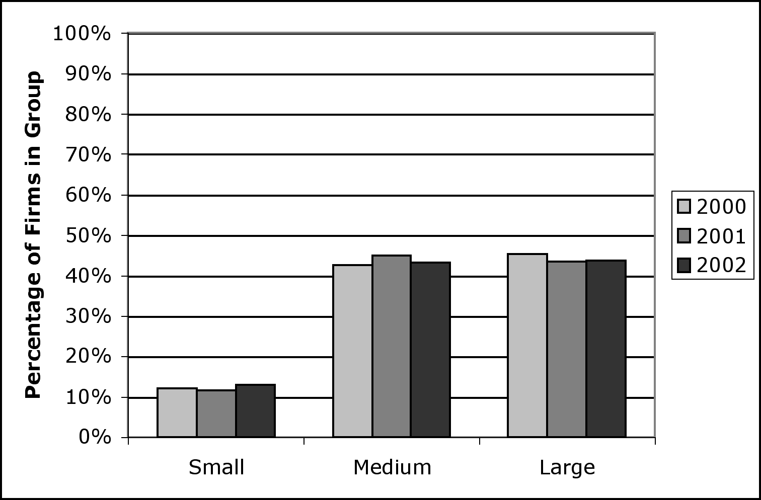

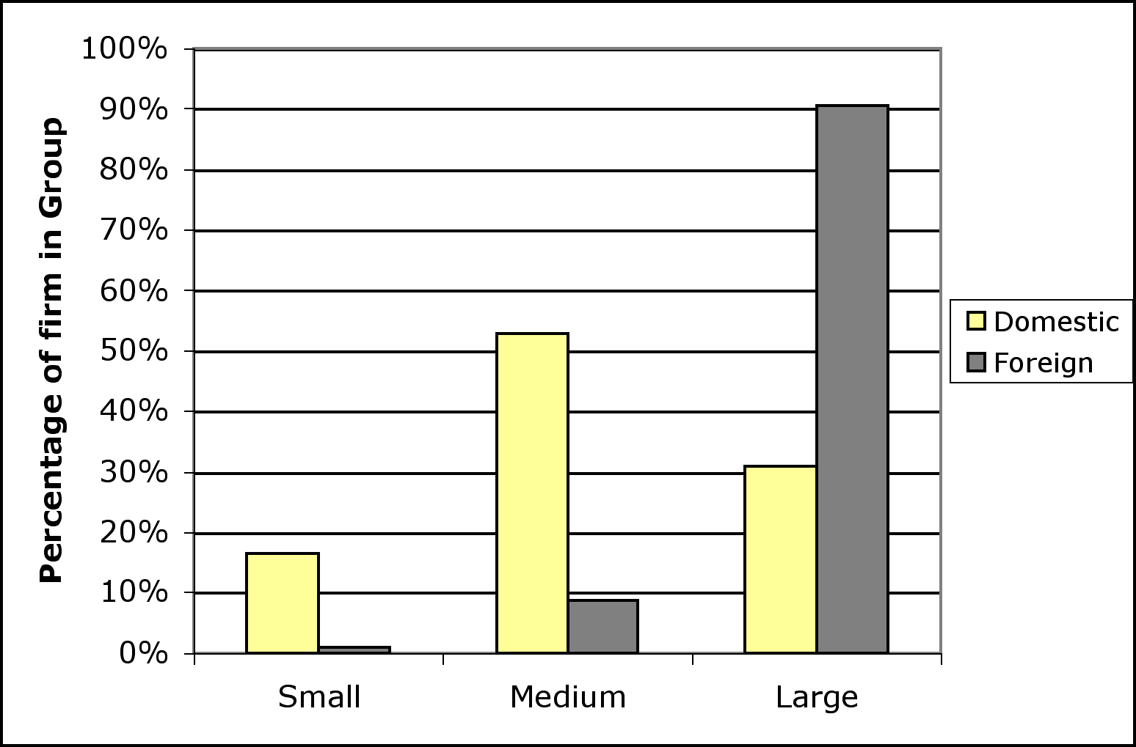
Source: Investment Climate Survey – Philippines, The World Bank (2002).

The correlation between foreign ownership of a firm and its size is obvious. If we regress the number of foreign-owned shares in 2002 on the logarithm of the firm size (expressed as the number of employees in 2002) we get
 | Number of foreign shares | R²
Log size | 13.57 | 0.38
 | (0.70)

The result is highly significant on 95% confidence level with p-value below 10^{–4}. Thus, if we compare two firms, one of them 1% bigger than other, the number of foreign shares in the latter is larger by 13.6%. (This interpretation is of course valid for large and, to some extent, for medium-size firms.)

The overall ownership structure profile of the firms is shown in Figure 3.2. On average, around 16% of firms is foreign-owned. Also, the same result is obtained on individual-firm level: each firm has about 16% of foreign capital on the average. None of the firms in the data set had any shares owned by the Philippine Government.

Figure 2: Ownership structure of firms

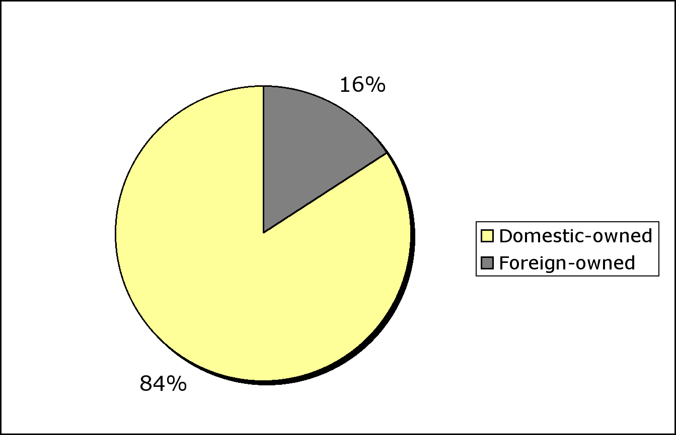
Source: Investment Climate Survey – Philippines, The World Bank (2002).

Firm characteristics substantially differ by size and ownership structure (Table 2.2). For example, the average size of a large firm is almost by a factor of ten greater than the average size of a small firm, whereas the average size of a foreign-owned firm is about six times greater than that of a domestic-owned firm. Note that distribution by size is non-uniform, but rather exponential: while small and medium firms have median size close to the average, the median size of large firms is a half of the average. Also, the median size of foreign-owned firms is around eighteen times bigger than for the domestic-owned ones. This is perhaps the best illustration of large discrepancy between domestic and foreign ownership of production in Philippines. Foreign-owned firms, however, are less likely to have planted more than one establishment, mostly because they are faced with bad infrastructure (cf. discussion about constraints to business expansion). In particular, transportation and telecommunication are significantly bigger problems for foreign than for domestic enterprises.Total income increases exponentially with firm size. Regression of the logarithm of total income on the logarithm of firm size gives

 | Log total income | R²
Log size | 1.376 | 0.71
 | (0.035)

with p-value less than 10^{–4}. Thus, scale effects in production are very pronounced.

Medium-sized and larger firms are more likely to export. The difference between the tendencies to export is very significant between small and medium, and medium and large firms. On the other hand, almost 90% of foreign-owned firms sell their good abroad, in comparison to 21% of domestic-owned firms. Share of sales in export is also much greater for the foreign-owned enterprises. This illustrates a major discrepancy in the exporting engagement between these two categories. Another important difference is manifested accross the fields in which firms specialize (Figure 2.3). While domestic-owned firms are mostly oriented to food and food-processing business, most of the electronic industry is owned by foreigners. The only industry that is evenly distributed among the firms, both by size and by ownership, is the garment manufacturing. This implies existence of a well-established market demand for this type of Philippine goods, both home and abroad.

Table 2.2: Firm characteristics by size and ownership structure
A.-By size
 | All | Small | Medium | Large
 |  | (0 to 10) | (11 to 99) | (100+)
Number of firms | 647 | 93 | 310 | 244
Average size | 322.5 | 8.3 | 34.3 | 808.4
Median size | 45 | 10 | 26 | 406
Number of establishments | 2.0 | 2.3 | 1.7 | 2.3
Percentage of firms that export | 33.7 | 1.1 | 16.9 | 62.2
Share of sales in export | 30.8 | 2.0 | 18.0 | 56.0
Total income 2002 (US$ 1,000) | 10,647 | 180 | 628 | 26,217
Food & food processing | 37.9 | 47.3 | 44.5 | 28.4
Textiles | 8.5 | 4.3 | 8.4 | 9.9
Garments | 37.3 | 48.4 | 37.1 | 34.2
Electronics & electrical machinery | 16.3 | 0.0 | 10.0 | 27.5

B.-By ownership
 | All | Domestic | Foreign
Number of firms | 647 | 502 | 118
Average size | 322.5 | 135.1 | 829.2
Median size | 45 | 28 | 508
Number of establishments | 2.0 | 2.1 | 1.6
Percentage of firms that export | 33.7 | 21.0 | 89.8
Share of sales in export | 30.8 | 16.9 | 86.7
Total income 2002 (US$ 1,000) | 10,647 | 4,643 | 29,011
Food & food processing | 37.9 | 45.7 | 5.5
Textiles | 8.5 | 10.0 | 3.2
Garments | 37.3 | 37.2 | 43.3
Electronics & electrical machinery | 16.3 | 7.1 | 48.0
Source: Investment Climate Survey – Philippines, The World Bank (2002).

Figure 2.3: Domestic- and foreign-owned firms by industry
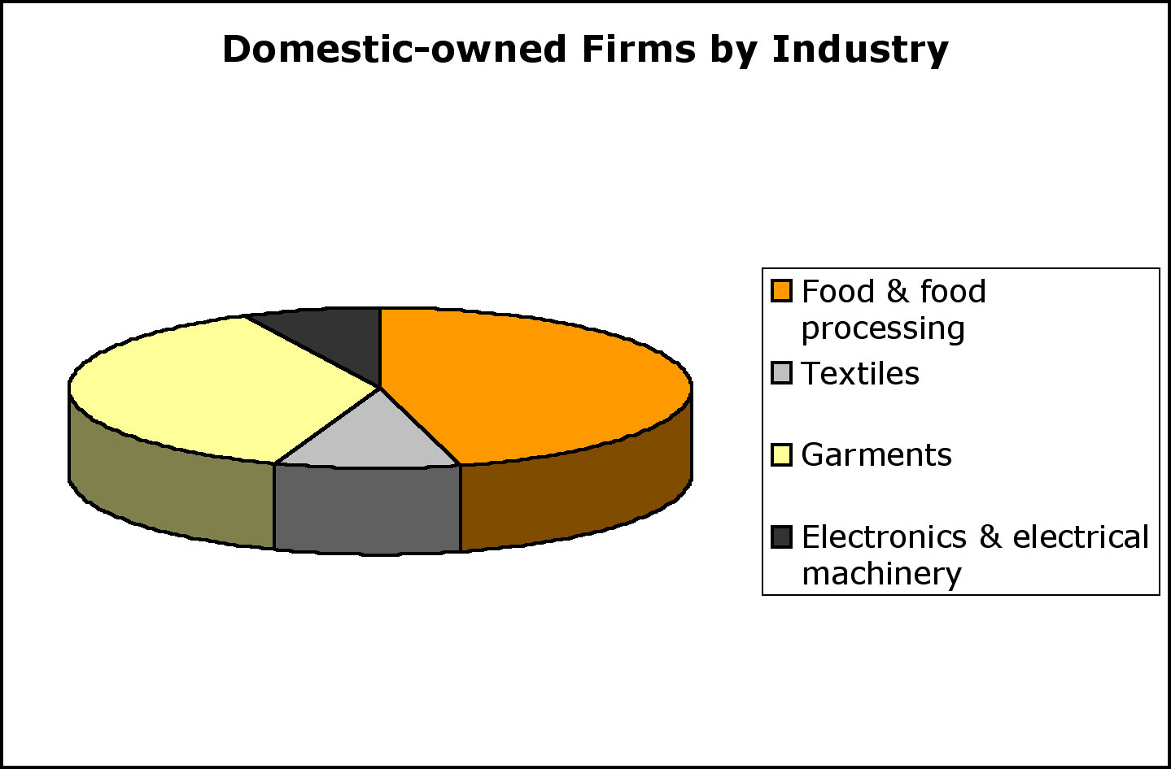

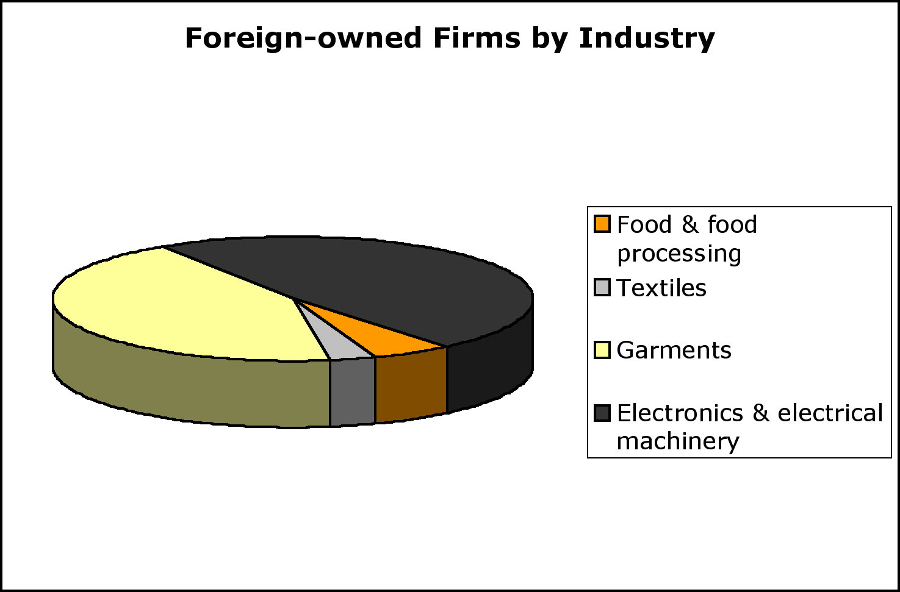
Source: Investment Climate Survey – Philippines, The World Bank (2002).

3.1. Employment dynamics

In this section we compare constrained (i.e. actual) and unconstrained (i.e. desired) employment policies of the firms. Each firm reported the number of workers that had been hired and fired (or quit their jobs for other reasons) during the year prior to the survey. From this, we can find estimates of gross employment creation and destruction, employment turnover and net employment creation. Then, we compare these with the firms’ unconstrained preferences, which are reflected by the employment policies the firms would conduct if they had no obstacles.

Table 3.3 shows actual employment policies across firms: gross employment creation, destruction, and turnover, as well as the net employment creation. We observe that for an average firm both the rate of employment creation and the rate of employment destruction were below 10 percent, leading to the employment turnover rate of less than 20 percent. Put differently, less than one out of five workers that were working in the firm at some point during 2002 either joined or left the firm in the same year. Moreover, the number of jobs created in domestic firms is less than the number of jobs destroyed, especially in small and large firms. (In fact, small domestic firms have the greastest employment destruction rate.) On the other hand, net employment creation is positive in the foreign firms, in particular in the medium-size ones.

Table 3.3: Employment creation, destruction and turnover
 | Total
 | All | Small | Medium | Large
 |  | (0 to 10) | (11 to 99) | (100+)
 | (% of workforce)
Employment creation | 7.6 | 9.0 | 7.9 | 6.4
Employment destruction | 9.5 | 12.6 | 9.3 | 8.6
Employment turnover | 17.0 | 21.6 | 17.2 | 15.1
Net employment creation | -1.9 | -3.6 | -1.4 | -2.2

 | Domestic
 | All | Small | Medium | Large
 |  | (0 to 10) | (11 to 99) | (100+)
 | (% of workforce)
Employment creation | 7.7 | 13.8 | 7.8 | 6.1
Employment destruction | 10.4 | 23.6 | 9.4 | 11.5
Employment turnover | 18.1 | 37.4 | 17.2 | 17.6
Net employment creation | -2.7 | -9.8 | -1.6 | -5.4

 | Foreign
 | All | Small | Medium | Large
 |  | (0 to 10) | (11 to 99) | (100+)
 | (% of workforce)
Employment creation | 8.1 | - | 10.6 | 7.9
Employment destruction | 7.1 | - | 6.8 | 7.3
Employment turnover | 15.2 | - | 17.4 | 15.1
Net employment creation | 0.9 | - | 3.8 | 0.6

Source: Calculations based on Investment Climate Survey – Philippines (2002).
Employment creation: number of workers hired during the year prior to the survey divided by total number of workers employed in the firm.
Employment destruction: Numbers of workers separated from the firm (i.e. firing and quitting) during the year prior to the survey divided by total number of workers employed in the firm.
Employment turnover: Employment creation + employment destruction.
Net employment creation: Employment creation – employment destruction.

The unconstrained preferences of the firms are in contrast with employment policies they practice. Around 40 percent of all firms would prefer to increase the number of permanent workers if faced with no constraints, around 20 percent would decrease it, and around 35 percent would maintain it as it is. (Table 3.4). Using this data, a hypothetical optimal net employment creation rate is found to be 4.3 percent on the average (see Figure 4 and the tables therein). If we assume that existing constraints to employment creation are reflected by the differences between actual and desired policies, small domestic-owned firms face the highest obstacles to employment expansion. In the next section we discuss these constraints in more detail.

Table 3.4: Unconstrained employment policies

A.-By size
 | All | Small | Medium | Large
 |  | (0 to 10) | (11 to 99) | (100+)
Decrease | 22.7 | 16.3 | 24.6 | 22.6
Remain at same level | 35.0 | 45.7 | 33.8 | 32.5
Increase | 42.5 | 38.0 | 41.6 | 44.9

B.-By ownership

 | All | Domestic | Foreign
Decrease | 22.7 | 23.0 | 21.1
Remain at same level | 35.0 | 33.2 | 42.3
Increase | 42.5 | 43.8 | 36.6
Source: Calculations based on Investment Climate Survey – Philippines (2002).

Figure 3.4: Optimal employment and unconstrained employment policies

A.-By size
All | Small | Medium | Large
 | (0 to 10) | (11 to 99) | (100+)
4.3 | 5.2 | 3.4 | 5.0

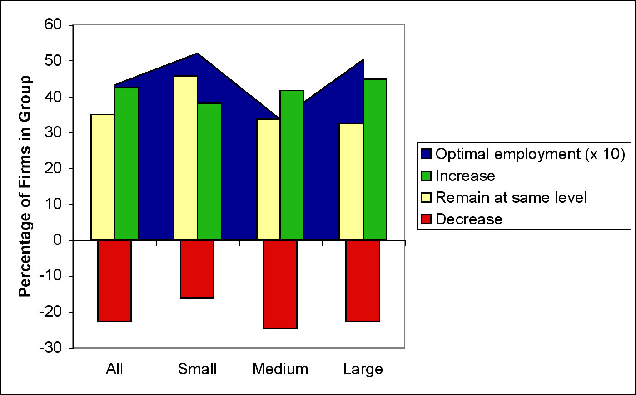

B.-By ownership

All | Domestic | Foreign
4.3 | 4.2 | 5.0

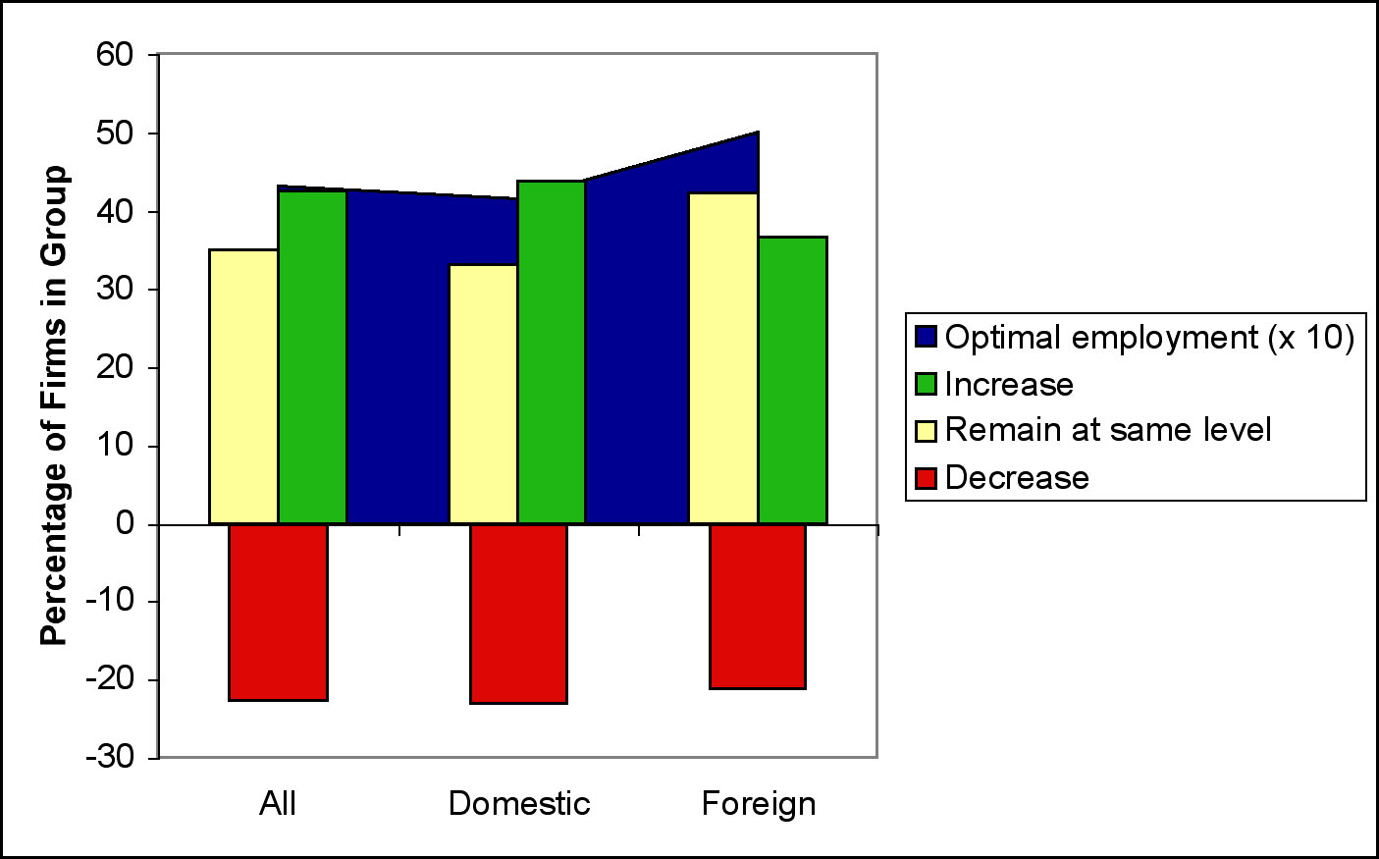
Source: Investment Climate Survey – Philippines, The World Bank (2002).

3.2. Constraints to employment creation and business expansion

The difference between actual and desired employment policies varies with firm size and ownership structure. We will try to find out what are the main reasons for this difference. Perhaps one of the biggest problems that the firms (small and medium-size domestic-owned ones in particular) face when hiring new employees is the quality of human capital stock. Firms were asked to report their satisfaction with new college graduates they hire (Table 5 and Figure 5). Evidently, there is a substantial lack of skills of newcommers in small and medium-size, and Philippine-owned, firms. For example, there is a 78.5% probability that a new college graduate hired by a small firm would be unsuitable for the job, compared to 35.7% if hired by large, or only 27.1% if hired by a foreign-owned firm. There is an obvious positive correlation between the quality of skills of new employees and the size of a firm. A probit estimate of suitability of new graduates versus the logarithm of the firm size gives +0.296 (0.031) for the coefficient, 0.459 for the predicted probability, and 0.117 (0.012) for the derivative (the p-value being less than 10^{–4}). Therefore, almost as a rule, best graduates tend to work for large foreign companies, mostly in electronic industry. Small and medium-size domestic enterprises are thus forced to compete in food or garment-manufacturing markets where large number and high quality of college-educated workers is not a critical issue for business expansion.

Table 5: Are new college graduates suited to the needs of your establishment?
 | All | Small | Medium | Large
 |  | (0 to 10) | (11 to 99) | (100 +)
Yes | 44.9 | 21.5 | 35.3 | 64.3
No | 55.1 | 78.5 | 64.7 | 35.7

 | All | Domestic | Foreign
Yes | 44.9 | 37.0 | 72.9
No | 55.1 | 63.0 | 27.1
Source: Investment Climate Survey – Philippines, The World Bank (2002).

Figure 5: Are new college graduates suited to the needs of your establishment?

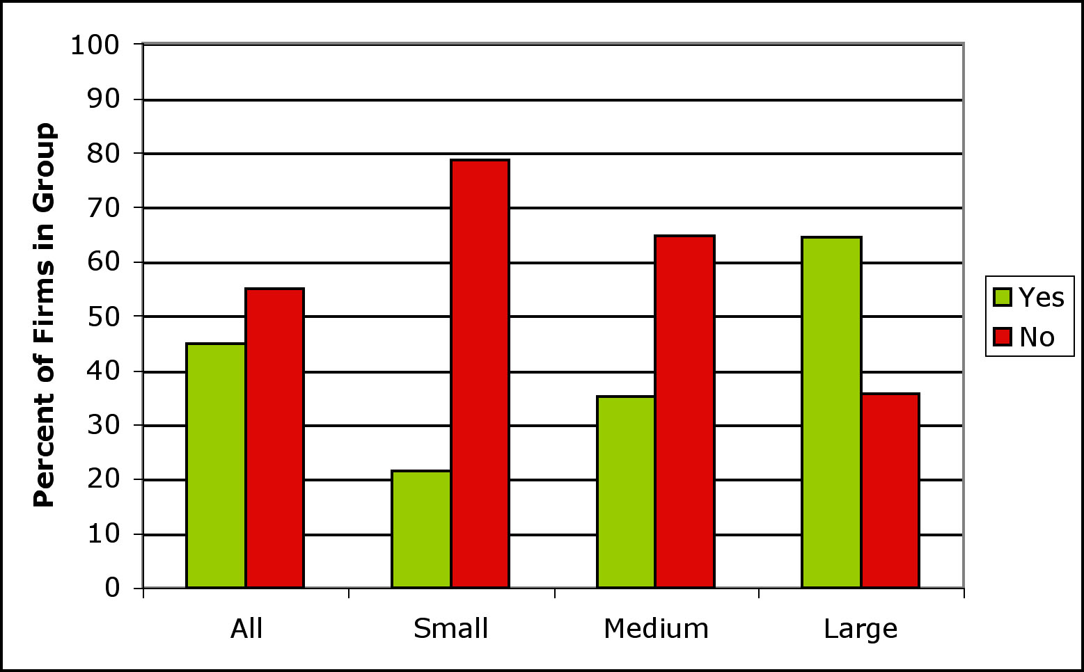

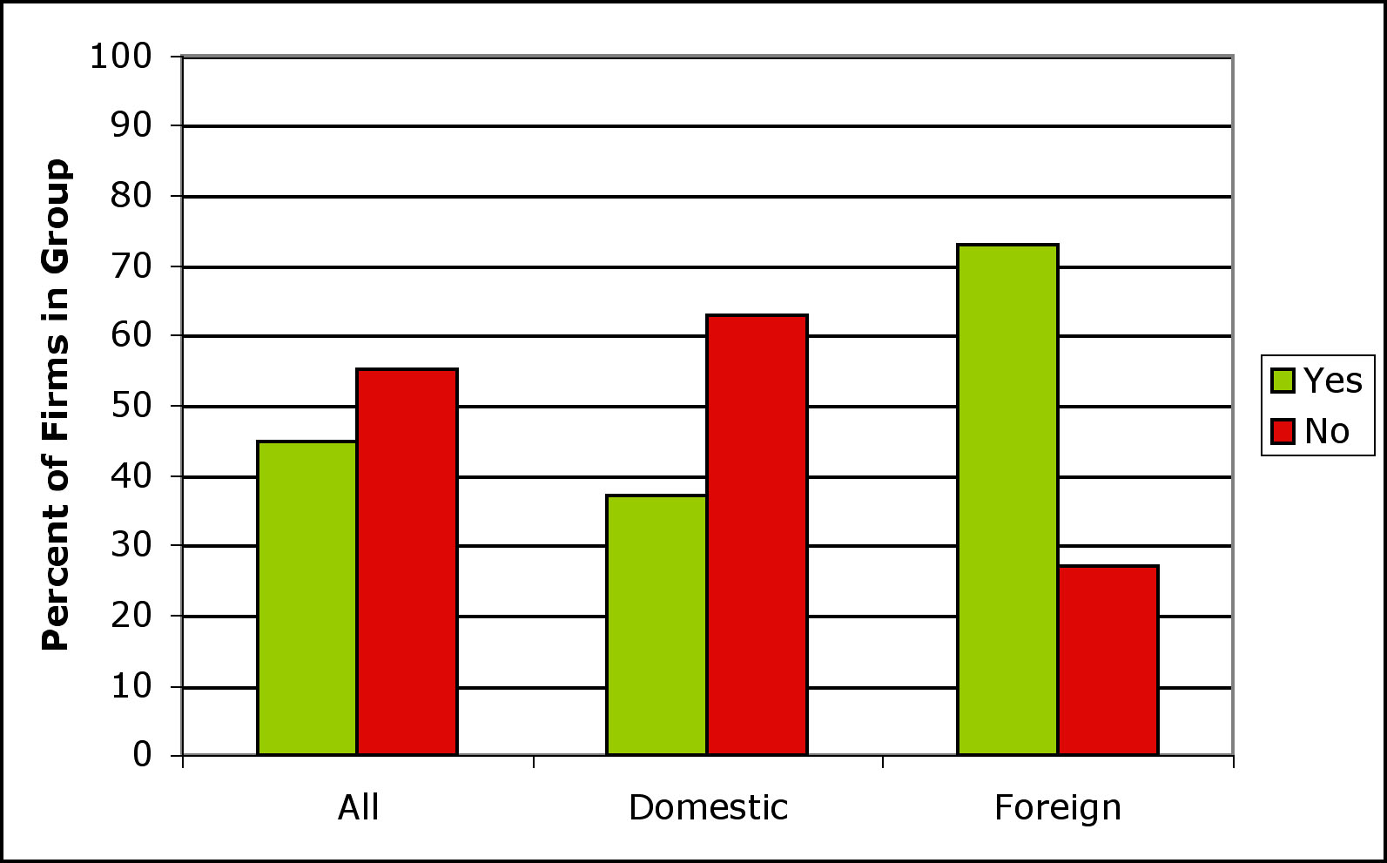
Source: Investment Climate Survey – Philippines, The World Bank (2002).

Inadequate skills of the employees are often one of the important factors that business doesn’t grow at desired level. Typically, firms in Philippines are unsatisfied with the quality of skilled production workers (Table 3.6): number of workers in this category that needs training is more than double of that in the other categories, and this figure goes to almost 39% in the foreign-owned firms. Notice, however, that foreign-owned and/or large enterprises tend to report rather a low level of satisfaction with their workforce. The reason why they still don’t fire that many people are high firing costs and other unfavorable labor regulations, which severely affect large companies (cf. Table 3.7). In contrast, small businesses are less transparent so they do not face this constraint to the same extent.

Table 3.6: Proportion of workforce that needs training
 |  |  | All | Small | Medium | Large
 |  |  |  | (0 to 10) | (11 to 99) | (100 +)
Management |  |  | 13.6 | 7.7 | 8.4 | 22.0
Engineers/Accountants |  |  | 12.1 | 1.1 | 7.5 | 21.5
Skilled production workers |  |  | 27.3 | 21.7 | 24.3 | 33.0
Unskilled production workers |  |  | 16.4 | 9.1 | 14.3 | 21.6
Non-production workers |  |  | 11.9 | 2.3 | 9.9 | 17.6

 |  |  | All | Domestic | Foreign
Management |  |  | 13.6 | 10.2 | 30.6
Engineers/Accountants |  |  | 12.1 | 9.0 | 28.0
Skilled production workers |  |  | 27.3 | 25.6 | 38.7
Unskilled production workers |  |  | 16.4 | 14.6 | 28.1
Non-production workers |  |  | 11.9 | 9.5 | 25.2

Source: Investment Climate Survey – Philippines, The World Bank (2002).

When asked about “outside” constraints to business expansion, most of the firms identified macroeconomic instability, corruption, and poor electrical system as the most significant bottlenecks to growth. Table 3.7 and Figure 3.6 show the percentage of firms that find a particular constraint to be a major or severe obstacle.

Bad economic environment in general is perceived to be the greatest obstacle for expansion. This is stated almost unanimously by small, medium-sized and large enterprises, both domestic and foreign. In this category, macroeconomic instability is by far the biggest problem to business growth in Philippines: 38 percent of all the firms see it as such. Economic policy uncertainty affects large businesses most. Medium-size and large (mostly foreign-owned) firms find corruption to be more severe an obstacle than the small, domestic-owned ones. Also, enterprises that are foreign-owned are more affected by crime, theft and disorder.

Not surprisingly, the second-to-worst category that prevents growing are the regulations concerning taxes, customs and various permits. For example, on the average firms report that the maximum number of days they need to clear the imports on the customs is around 18 (compared to only 12 in India, say). The custom regulations particularly affect foreign-owned and/or larger firms. High tax rates are another important issue, and they posit a big problem for medium-size business.

Poor infrastructure (electricity in particular and, to some extent, transportation), unfavorable labor regulations, and scarce and costly financial resources are somewhat less, but still significantly, constraining the future expansion. For instance, one third of all the firms have major problems with electricity, and one quarter of large (and even 28 percent of the foreign) firms reports substantial problems with transportation. Cost and access to financing is much bigger problem for domestic-owned companies; medium-size firms are the ones who suffer most. The last, but not the least, labor regulations make most of the problems in governing human capital, and this issue becomes worse the bigger the firm is.

Interestingly, most of these constraints appear to be more binding for larger and/or foreign-owned firms than for small-to-medium or domestic enterprises. For example, large firms are the ones that are constrained most by custom problems and inefficiencies, which should not be surprising given that it is precisely these firms that are most likely to export all or part of their production.

Table 3.7: Firms of different sizes and ownership structure face different constraints to growth and expansion

A.-By size
 | Small | <-difference-> | Medium | <-difference-> | Large
 | (0 to 10) |  | (11 to 99) |  | (100+)
Infrastructure
Telecommun. | 0.05 |  | 0.07 | ** | 0.17
Electricity | 0.25 |  | 0.36 |  | 0.34
Transportation | 0.09 | * | 0.15 | ** | 0.25
Access to land | 0.09 |  | 0.14 | ** | 0.18
Taxes, customs and permits
Tax rates | 0.24 | * | 0.32 |  | 0.31
Tax administration | 0.22 |  | 0.25 |  | 0.26
Customs | 0.08 | ** | 0.17 | ** | 0.31
Licenses and permits | 0.08 | ** | 0.13 |  | 0.15
Financial resources
Cost of financing | 0.20 |  | 0.26 |  | 0.20
Access to financing | 0.12 |  | 0.15 |  | 0.13
Economic environment
Economic policy uncertainty | 0.24 |  | 0.27 | ** | 0.34
Macroeconomic instability | 0.34 |  | 0.38 |  | 0.40
Corruption | 0.25 | ** | 0.35 |  | 0.39
Crime, theft and disorder | 0.24 |  | 0.26 |  | 0.27
Anti-competitive practices | 0.19 | * | 0.26 |  | 0.24
Labor
Labor regulations | 0.13 | ** | 0.22 | ** | 0.32
Workforce skill level | 0.06 |  | 0.12 | * | 0.14

B.-By ownership
 | Domestic | <-difference-> | Foreign | All
Infrastructure
Telecommun. | 0.09 | ** | 0.22 | 0.11
Electricity | 0.33 |  | 0.35 | 0.33
Transportation | 0.16 | ** | 0.28 | 0.18
Access to land | 0.14 |  | 0.17 | 0.15
Taxes, customs and permits
Tax rates | 0.32 |  | 0.24 | 0.30
Tax administration | 0.25 |  | 0.24 | 0.25
Customs | 0.19 | ** | 0.35 | 0.22
Licenses and permits | 0.13 |  | 0.16 | 0.14
Financial resources
Cost of financing | 0.25 | * | 0.15 | 0.23
Access to financing | 0.15 | ** | 0.08 | 0.14
Economic environment
Economic policy uncertainty | 0.29 |  | 0.30 | 0.30
Macroeconomic instability | 0.40 |  | 0.33 | 0.38
Corruption | 0.34 | ** | 0.40 | 0.35
Crime, theft and disorder | 0.25 | ** | 0.32 | 0.26
Anti-competitive practices | 0.25 |  | 0.19 | 0.24
Labor
Labor regulations | 0.23 | ** | 0.34 | 0.25
Workforce skill level | 0.11 | ** | 0.18 | 0.12

Source: Calculations based on Investment Climate Survey – Philippines (2002).
** (*) Difference between both values is significantly different from zero at the 5 (10) percent level.

Figure 3.6: Constraints to daily business operation and future expansion
(Percentage of firms that perceives each factor to be a constraint)

A.-By size

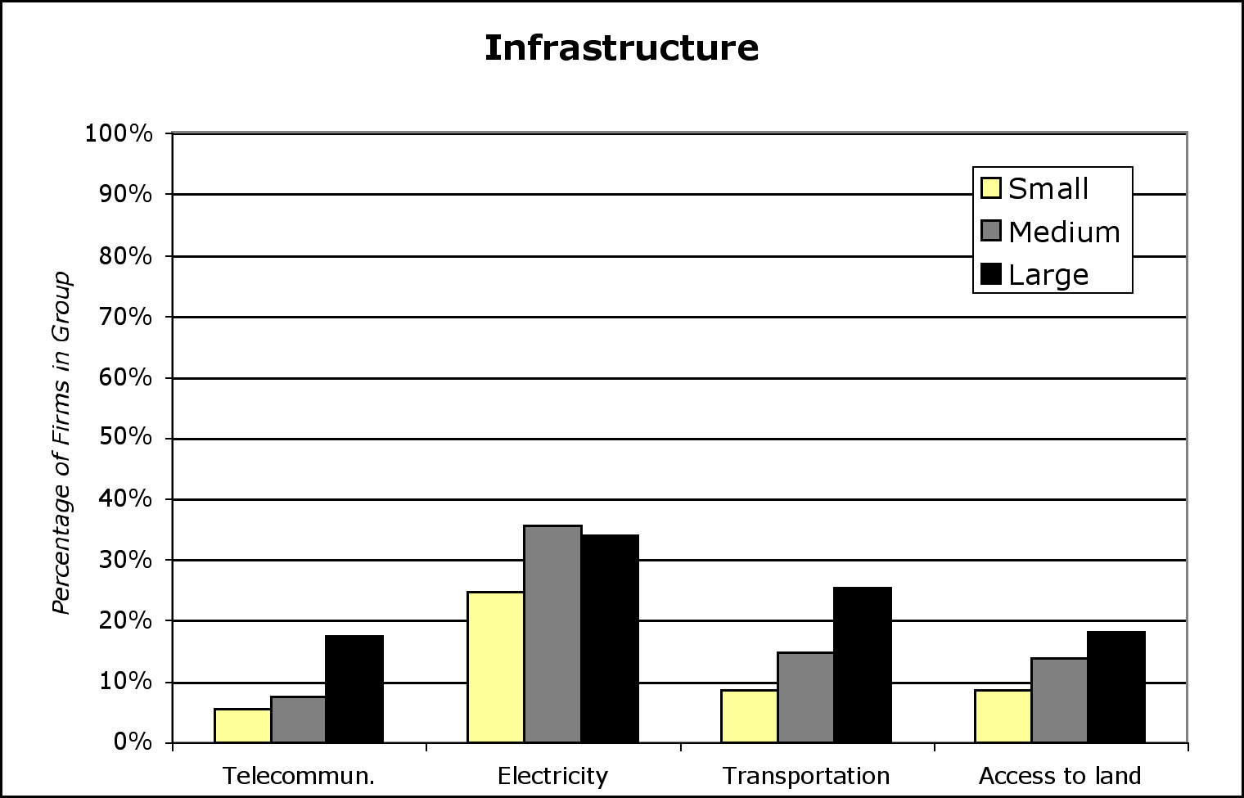

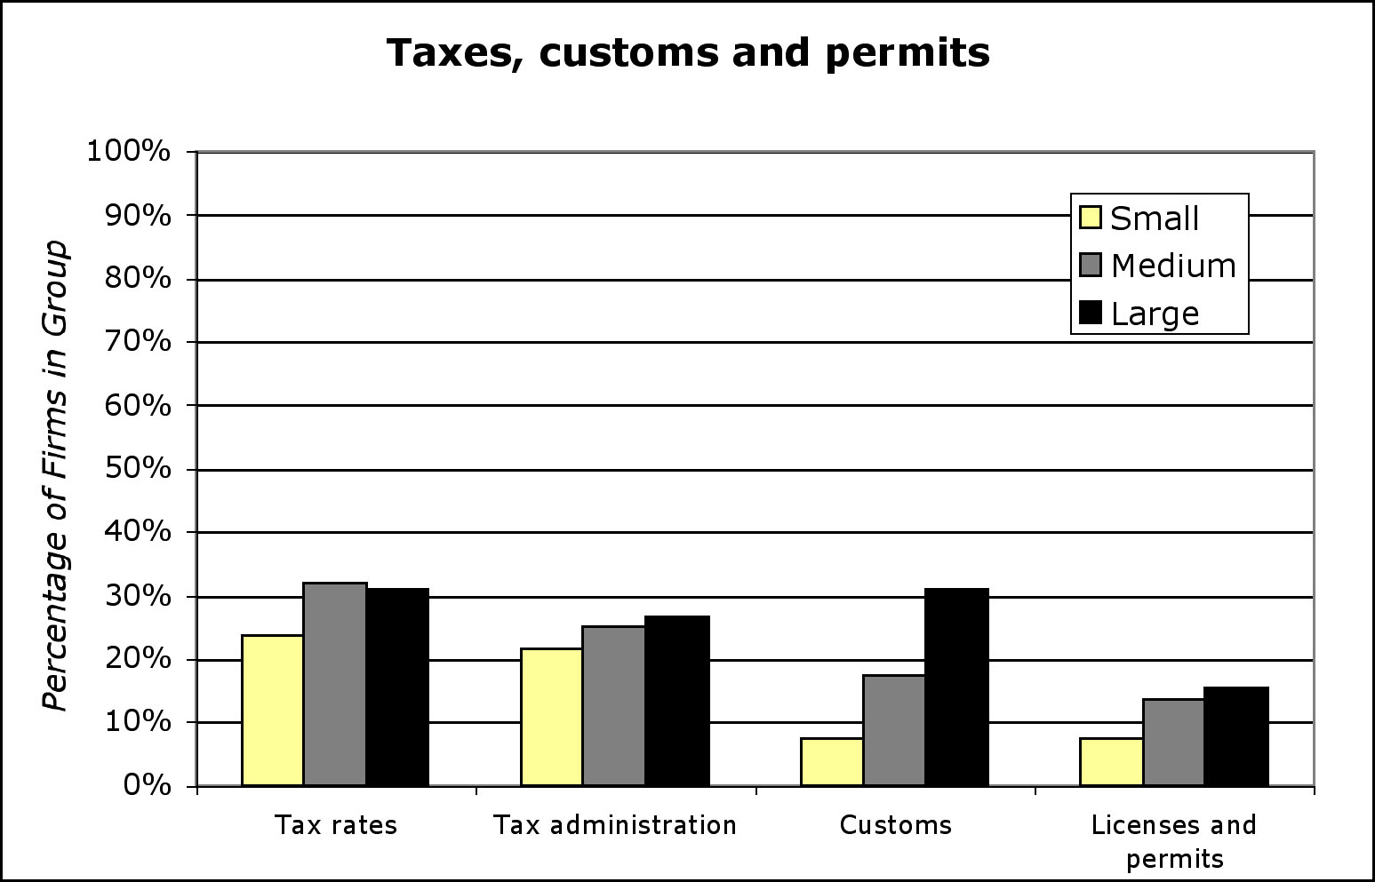
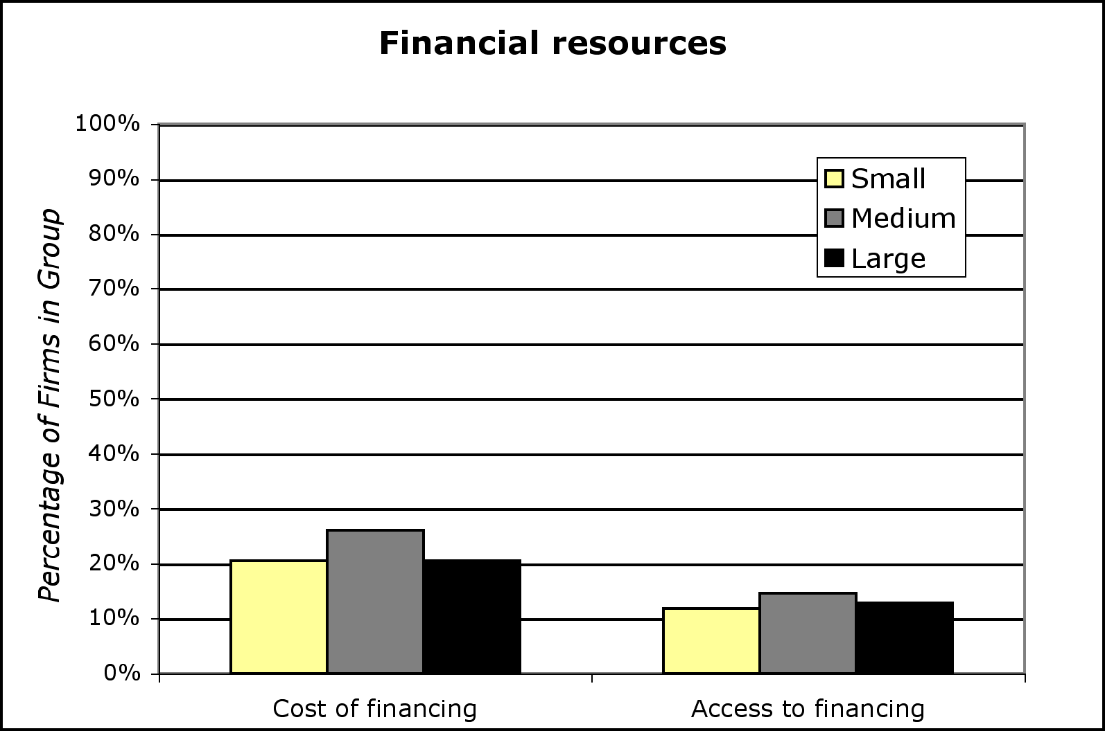

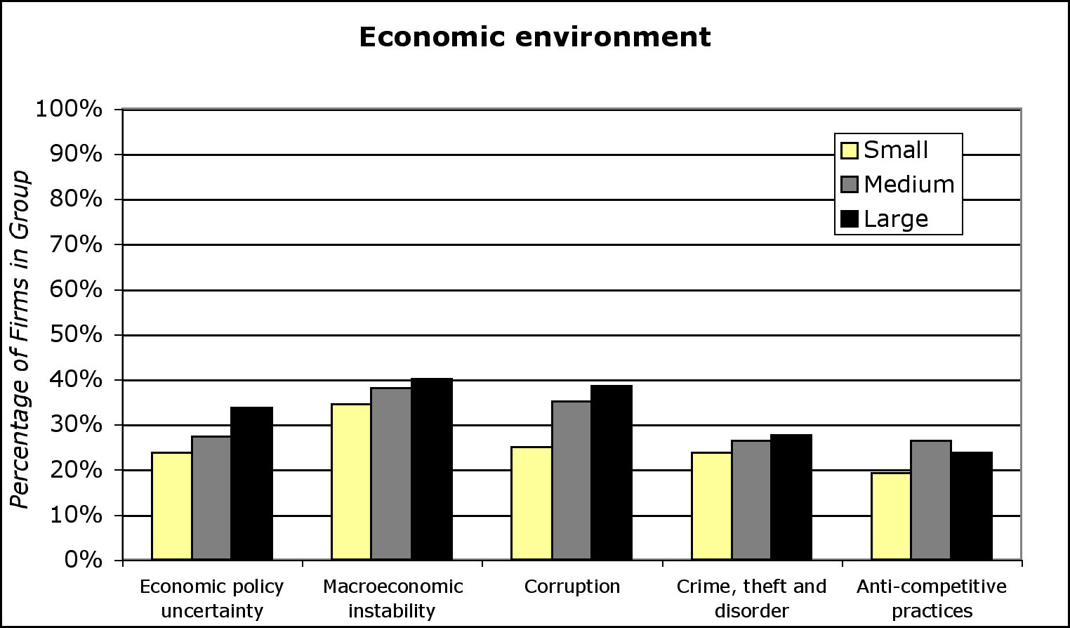

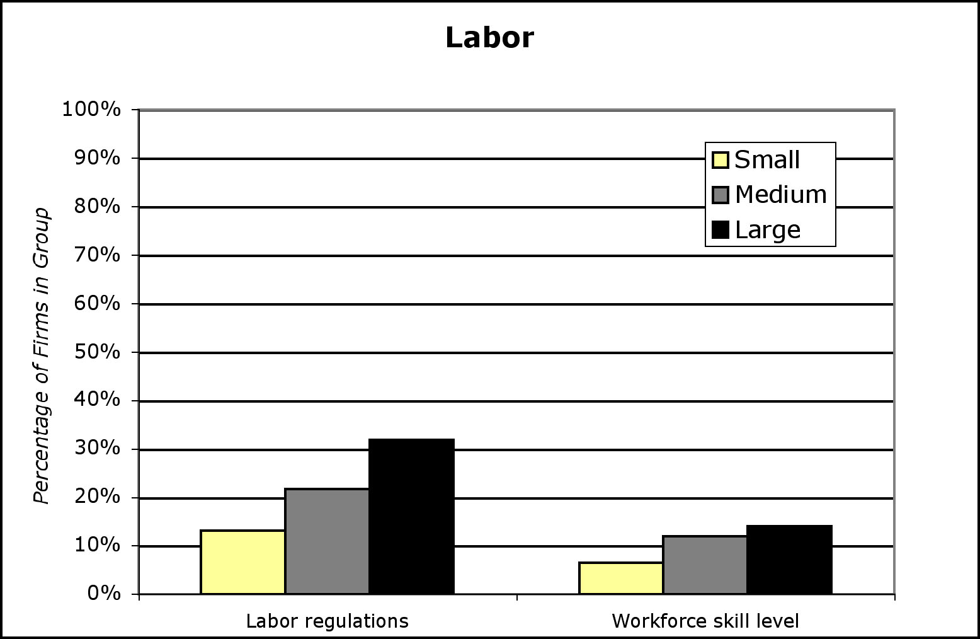

B.-By ownership

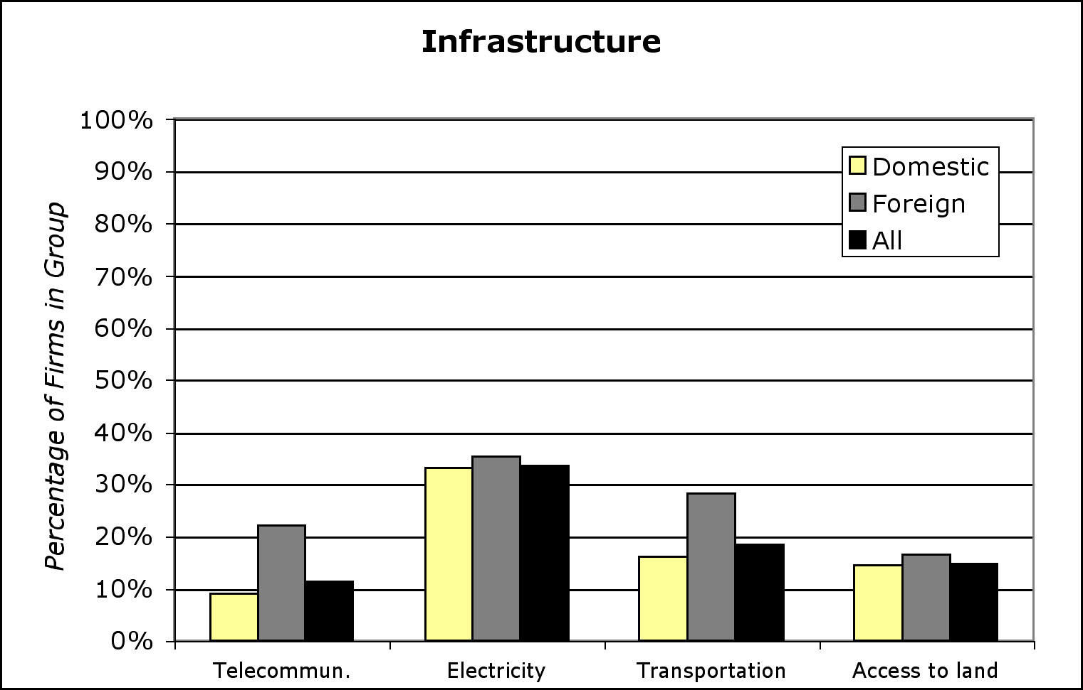

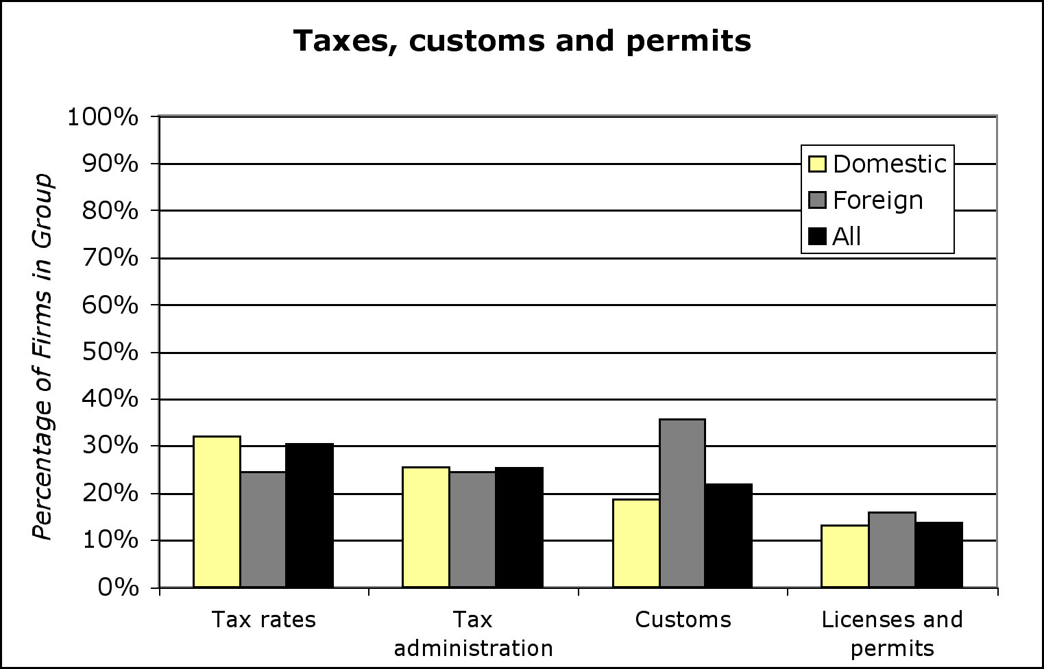
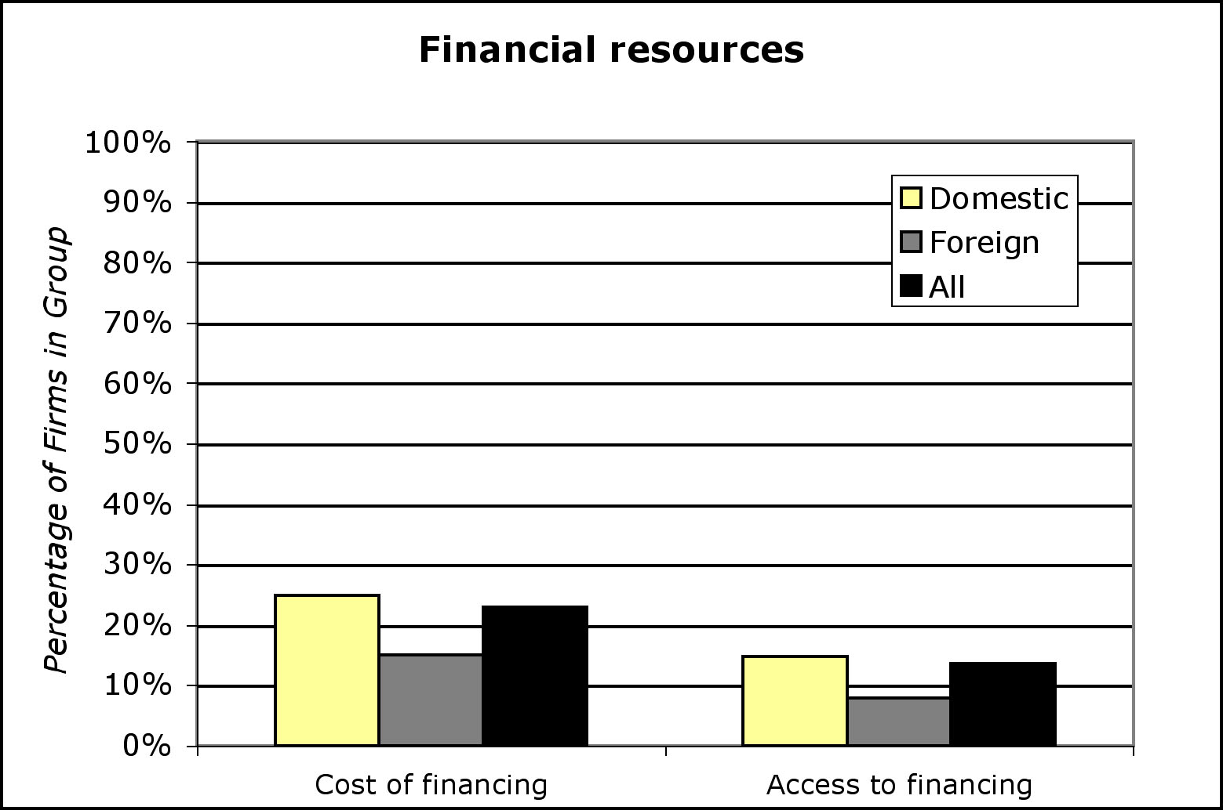

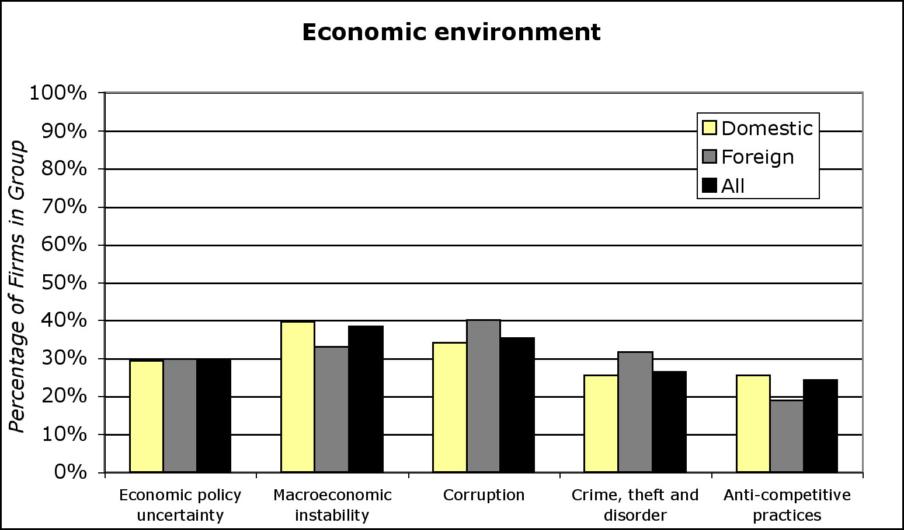

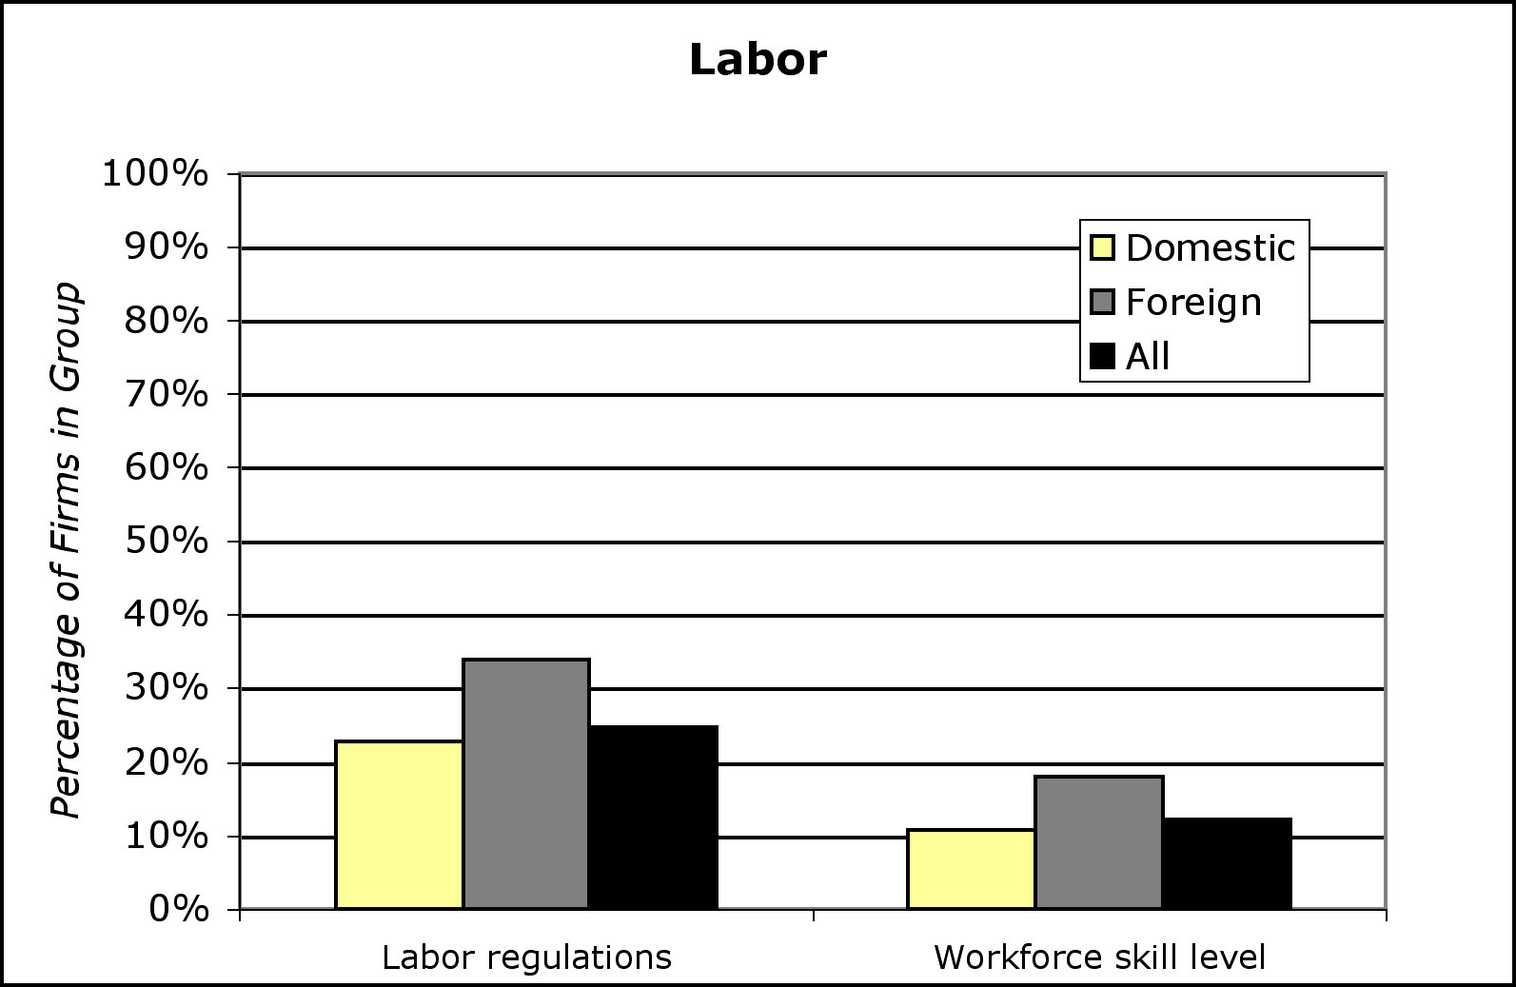
Source: Investment Climate Survey – Philippines, The World Bank (2002).

To conclude this section, we report the results of the overall business environment as seen by the firms (Table 3.8 and Figure 3.7). Unfortunately, most of the firms (41.2 percent) perceive the situation as “moderately declining”, and this finding is significant with 95% confidence. On average, situation is worse for small-to-medium than for the large enterprises. Almost 74 percent of small firms report a downhill tendency of the business climate, 30.4 percent of which find it to be sharply declining. Taking this into account and bearing in mind previously established correlation between ownership structure and size, it comes as no surprise that domestic firms are the ones who suffer more than the foreign-owned ones. One out of four domestic firms finds the environment to be deteriorating.

Table 3.8: Overall business environment
(Percentage of firms that perceives degree and direction of change)

 | All | Small | Medium | Large
 |  | (0 to 10) | (11 to 99) | (100 +)
Sharply declining | 24.0 | 30.4 | 26.1 | 19.6
Moderately declining | 41.2 | 43.5 | 40.7 | 41.1
Not changing | 17.1 | 15.2 | 17.3 | 17.5
Moderately improving | 16.7 | 10.9 | 15.6 | 20.4
Sharply improving | 0.7 | 0.0 | 0.3 | 1.4

 | All | Domestic | Foreign
Sharply declining | 24.0 | 25.5 | 16.9
Moderately declining | 41.2 | 42.1 | 37.1
Not changing | 17.1 | 16.3 | 21.0
Moderately improving | 16.7 | 15.7 | 22.6
Sharply improving | 0.7 | 0.4 | 2.4
Source: Investment Climate Survey – Philippines, The World Bank (2002).

Figure 3.7: Overall business environment
(Percentage of firms that perceives degree and direction of change)

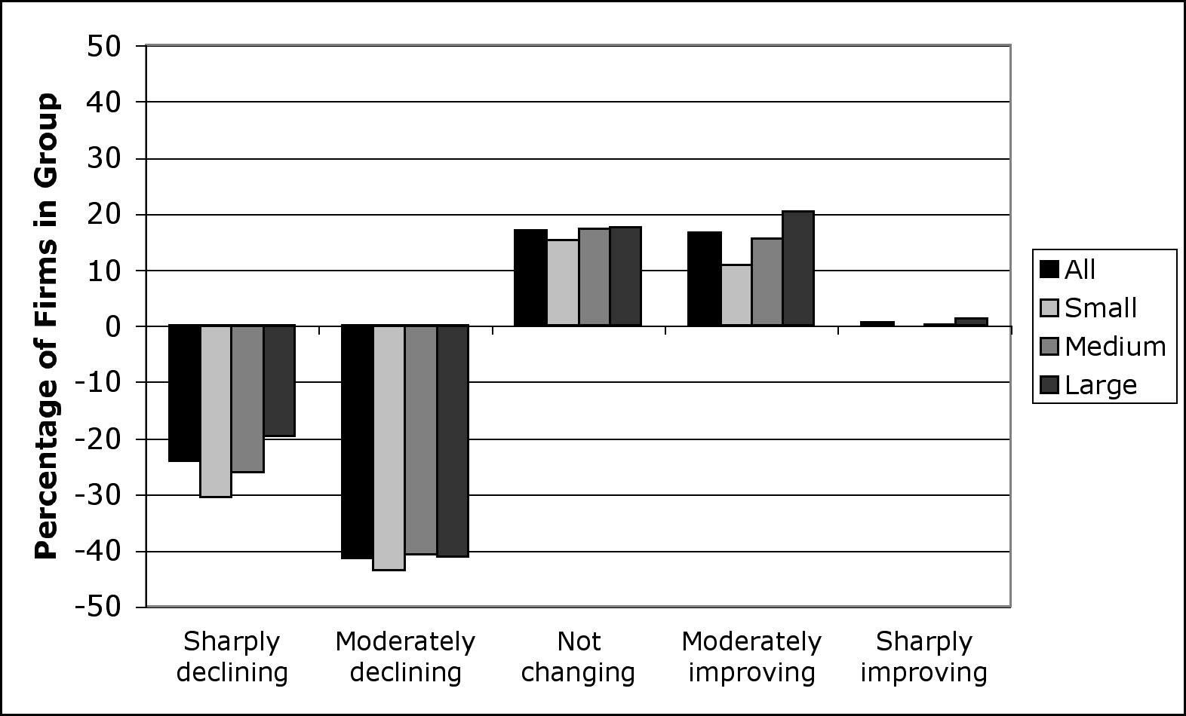

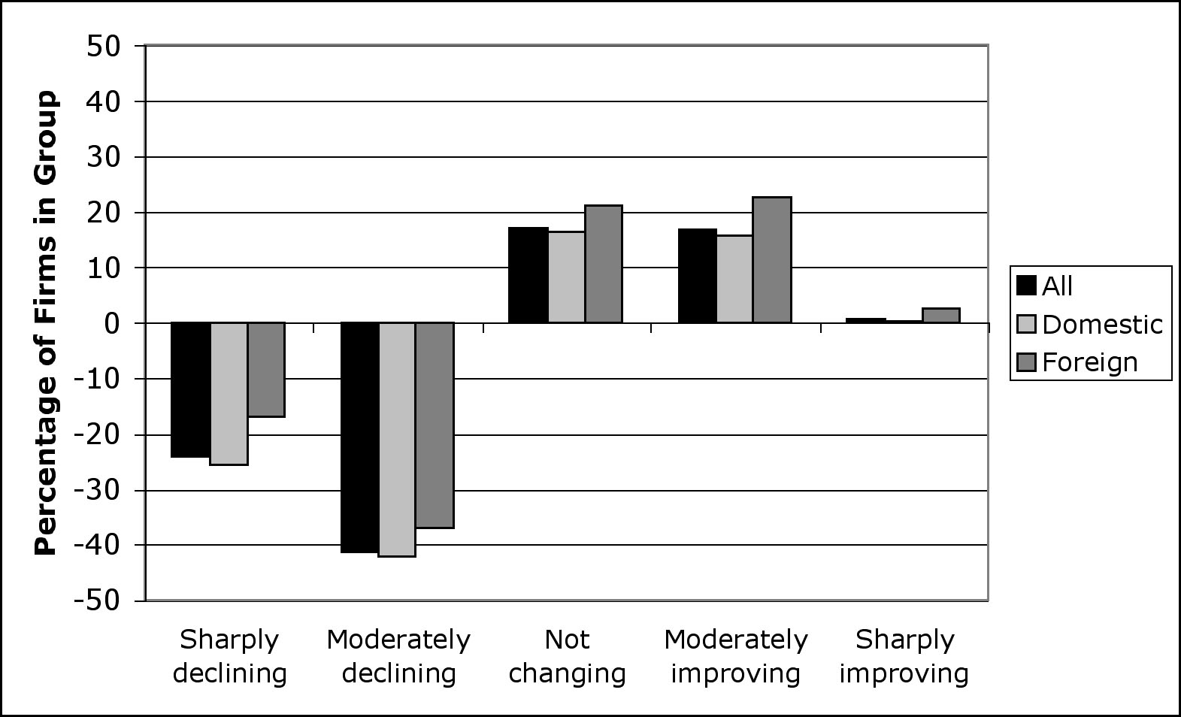
Source: Investment Climate Survey – Philippines, The World Bank (2002).

3.3. Actual employment creation and labor productivity

A common basis to compare different firms is by their output per worker. Usual proxy is the labor productivity, measured as the dollar value of production per worker employed. According to the survey, labor productivity is positively correlated with firm size – workers in large firms are more productive than in the small ones (Figure 3.8). These differences are the result of several important factors. Larger firms are more likely to use physical capital and to have access to better technologies than the small firms. Also, for a foreign-owned and/or large firm there is a higher probability that it will devote part of the production to exports and hence become exposed to international competitive pressures.

In the short run, labor productivity has a slowly increasing trend over time for medium-size and large firms, and shows cyclical behavior for small firms. Most of the increase occurred between 2001 and 2002, particularly for small and large firms that had increases in labor productivity of US$4.55 (after a decline of almost US$10 a year before) and US$2.36 per worker, respectively. A cyclical pattern is also observed for domestic-owned firms. In contrast, foreign-owned firms show a moderate increase in labor productivity, with a level of US$23.16, compared to US$19.11 of their domestic-owned counterparts in 2002.

Figure 3.8: Labor productivity across firms

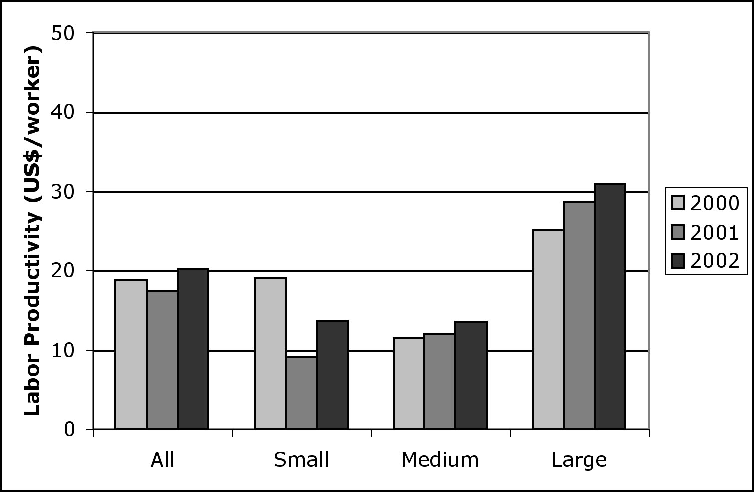

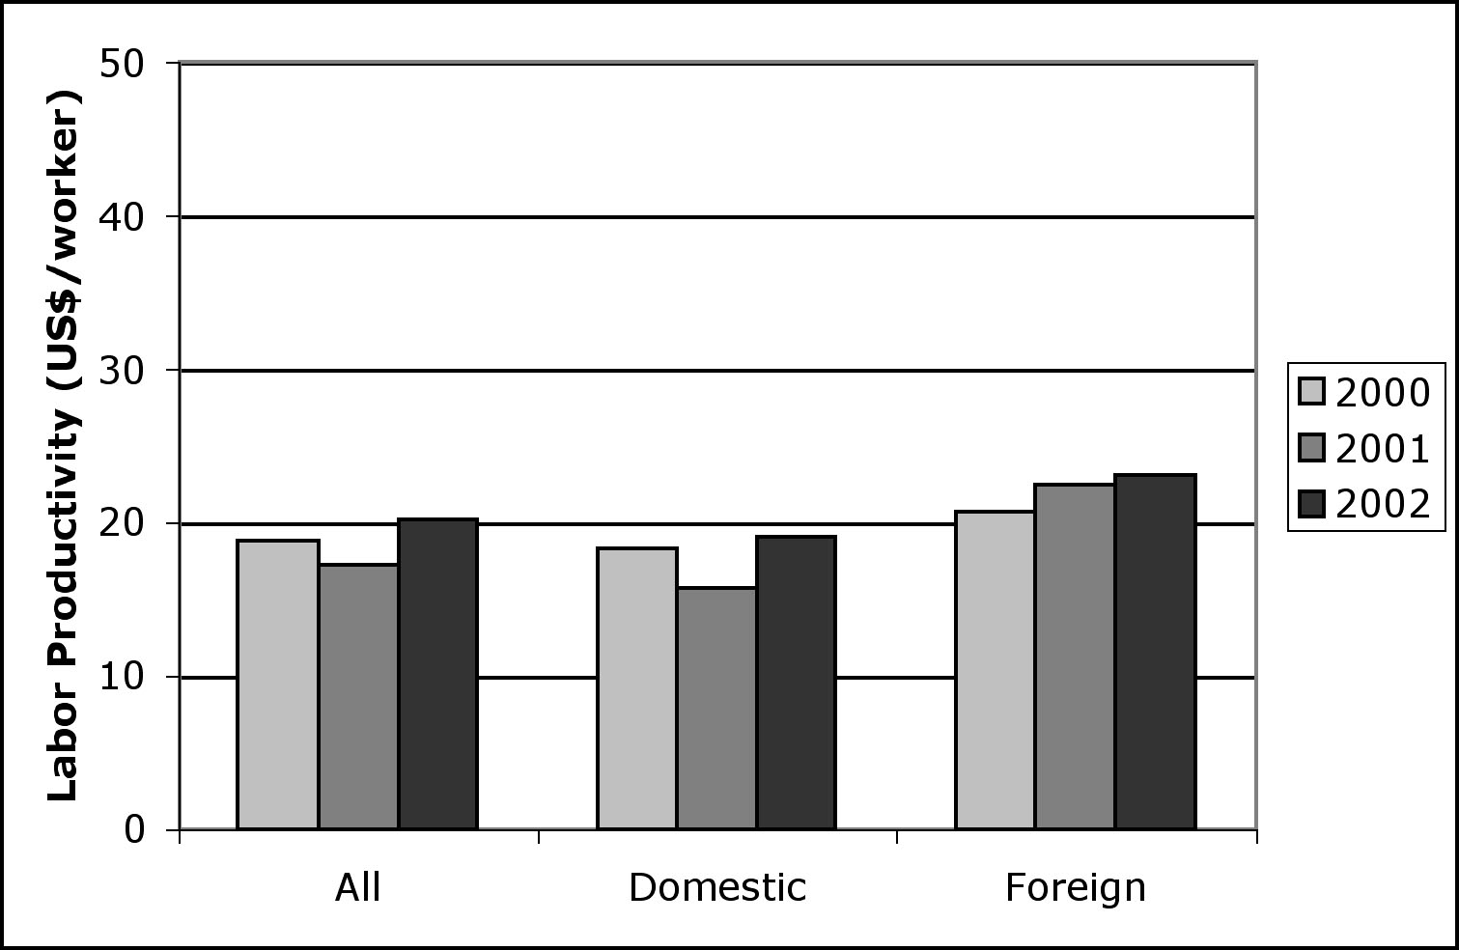
Source: Calculations based on data from the Investment Climate Survey – Philippines (2002).

The determinants of labor productivity and the relationship between this variable and employment creation are shown in Table 3.9. To see what are determinants of labor productivity of a firm, we regress the logarithm of labor productivity on logarithm of the firm size, number of foreign shares (expressed as a number between 0 and 1), the exporter dummy, average years of education of employees, and logarithm of number of skilled production workers. As Figure 3.8 suggests, the size of the firm plays a crucial role in labor productivity. The results of regression show that number of employees and the fact that a firm is an exporter are positively correlated with labor productivity. For example, a percentage increase in size of a firm yields around 0.66% higher labor productivity. However, the number of foreign shares is, surprisingly, not significant. Also, firms with better educated staff tend to be more productive – the logarithm of labor productivity is positively correlated with average number of years of employees’ education. In Employment Dynamics section we discussed that the category of workers that most of the firms are unsatisfied with are the skilled production workers. The regression gives evidence that labor productivity of a firm is in fact negatively correlated with number of skilled production workers employed. We have verified that number of workers in any other category is not significantly (anti)correlated with productivity. This is an important conclusion that shows the weak link in the production process.

To find the determinants of employment creation, the net number of jobs created (in the year prior to the survey), defined as the difference between the number of workers hired and the number of workers that quit their jobs, is used as dependent variable. The regression of this variable on logarithm of labor productivity, logarithm of the firm size, number of foreign shares, the exporter dummy, average years of education of employees, and logarithm of number of skilled production workers shows there is a single significant determinant of employment creation, and that is the number of foreign shares. In fact, as regression coefficient suggests, a 10% increase in foreign ownership leads (on average) to net opening of around four new jobs per year in the firm.

Table 3.9: Determinants of labor productivity and its relation with employment creation

 | Dependent Variable
 | Log labor productivity | Net Jobs Created
Log labor productivity |  | 1.667
 |  | (3.450)
Log size | 0.662 ** | 1.923
 | (0.108) | (8.397)
Foreign shares | –0.158 | 40.219 **
 | (0.233) | (17.694)
Exports | 0.407 ** | –13.672
 | (0.193) | (14.315)
Average education of employees | 0.180 ** | 0.182
 | (0.038) | (2.865)
Log skilled production workers | –0.331 ** | –6.383
 | (0.092) | (6.988)
Number of observations | 465 | 438
Source: Calculations based on Investment Climate Survey – Philippines (2002).
^{** (*)} Significantly different from zero at the 5 (10) percent level.

4. Foreign direct investment and investment climate

Developing countries find mayor problems to finance investment and growth. Among the alternative financing possibilities foreign direct investment (FDI) has proven to be resilient even during financial crises as it happen in the East Asian financial crisis of 1997-98. In fact since the beginning of the 80’s there has been a clear trend towards FDI and portfolio investment in the composition of capital inflows around the world. FDI has an impact in the economy through, at least, two basic channels: it increases capital formation and it helps to transfer technology, skills and managerial inputs across countries.

In fact some researcher consider FDI as the “good cholesterol” since it is related with long term consideration, in contrast with debt flows which are viewed as “bad cholesterol” driven by speculative considerations. In fact Bosworth and Collins (1999) find that an increase of one dollar in FDI increases domestic investment in 1 dollar while portfolio investment has no statistical effect on domestic investment.

Foreign direct investment has played a very important role in the economic development of the countries in the Southeast of Asia. As a result, at least in part, of large FDI inflows, Malaysia and Thailand were growing at a very fast pace at least during the second part of the nineties (until the crisis). Agrawal (2000) finds that the impact of FDI inflows on GDP growth in the Southeast of Asia is very strongly positive during the late eighties and nineties and suggests the possibility of complementarities between foreign and national investment.

The literature on the determinants of FDI is very large. Recently Alburquerque, Loayza and Serven (2003) have looked again at the determinants of FDI. The conclude that there are two type of factors: global and local. Among the local factor they find evidence of the importance of trade openness, financial depth, government consumption over GDP, GDP growth volatility and institutional quality.

The importance of institutional quality and investment climate in the explanation of FDI and local investment is a hot area of research in the recent years. A good investment climate lowers the cost of doing business in foreign countries and, therefore, stimulates FDI. The cost of doing business in foreign countries is related with different issues: business regulation, labor regulation, bureaucracy, judicial hurdles, property rights, enforceability of the contracts and political and macroeconomic stability. Restrictive requirements on local ownership, red tape and economic instability would make a country less attractive for FDI.

4.1. Philippines and FDI

The participation of Philippines in the Southern Asia FDI is lower than most of the countries in the region. In fact taken into account all sources (BOI, PEZA, CDC and SBMA) total approved FDI for the first nine months of 2003 was down a 45% respect to the previous year. In 2002 the decrease was already a 33% respect to 2001. Moreover the proportion of FDI with respect to GDP in Philippines is below most of the countries in the region as shown in figure 4.1.

Figure 4.1. Proportion of FDI in GDP.
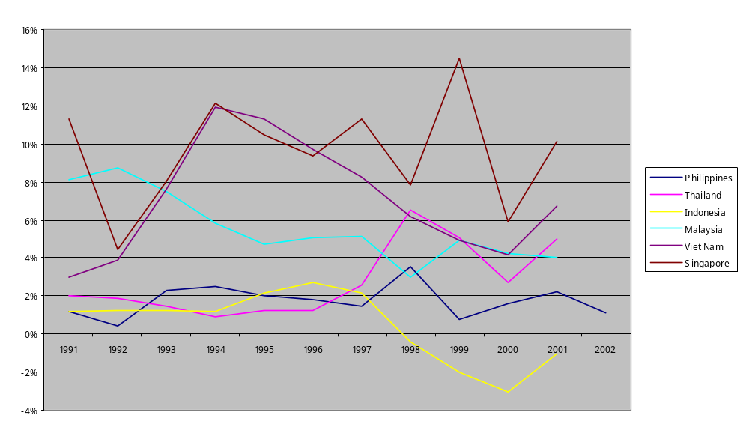
There are several reasons for the low performance of Philippines in attracting foreign direct investment. First of all, we show in previous sections how the investment climate of Philippines is one of the worst in the area. Obviously foreign investors take very seriously the difficulties of doing business in a country and react in accordance to this. Secondly Philippines can use remittances instead of FDI to cover its need for foreign exchange and to keep the value of its currency. The importance of remittances and workers overseas is extraordinary in the Philippines’ economy. To give just a few indications remittances are as high as to represent 15% of exports, 1047% of ODA, 298% of FDI or 8% of GDP. Therefore in Philippines the value of remittances is 4 times the amount of FDI! In fact the absolute volume of remittances was 6.4 billions in 2002 which implies that Philippines is the third country in the world in terms of remittances only below India (10 billions) and Mexico (9.9 billions).

It is true that remittances have been during the 90’s the least volatile source of foreign exchange earnings for developing countries (compare with FDI, ODA and stock markets). However the impact of FDI and remittances in the investment ability of the economy is very different since FDI concentrates in large firms investments while remittances go, if they are not consume, to small firms. As we show in the previous section the growth potential of small and large firms in Philippines is very different.
In this section we present a detailed analysis of the determinants of FDI in Philippines compare with the other countries of East Asia, South Asia and the Pacific region.

For this purpose we are going to use the most recent and detailed methodology of FDI available, which is described in a recent paper by Albuquerque, Loayza and Servén (2004). These authors consider basically two groups of determinants for FDI: local factors and global factor. Local factors are country-specific and have no direct, or indirect, impact on foreign direct investment across countries. Therefore these local determinants should include variables that affect the anticipated profitability from investing in the host country as well as the perceived volatility of profits. Global factors drive FDI into and from different countries. Table 4.1. reports the variables included in each category.

Table 4.1. Global and local determinants of FDI.
Global Factors | Local Factors
- G3 Average Interest Rate | - Trade Openness
- G3 Average Inflation | - Real Exchange Rate Growth
- World Stock Mkt Return | - GDP Growth
- U.S. Yield Curve Slope | - Financial Depth
- U.S. Credit Spread | - Government Consumption / GDP
- World Growth | - Institutional Quality
 | - GDP Growth Volatility
 | - Terms of Trade Volatility
 | - Real Exchange Rate Volatility
 | - Wages
 | - Stock Mkt Traded Value / GDP
 | - Privatizations
 | - Balance of Payments Restrictions

Table 4.2 reproduces the basic results found by Alburquerque, Loyaza and Serven (2004). The coefficients are obtained using the fixed effects panel data estimator. With respect to the global factors the increase in the performance of international assets (G-3 average bond rate, slope of the US yield curve and the growth rate of world per capita GDP) have a negative effect on FDI. The index of global stock market returns and the US credit spread are not significantly different from 0. Among the local determinants the growth rate of GDP per capita and the measure of trade openness are positive and significantly different from 0 while government consumption has a negative coefficient. Improvement in productivity, measured by higher economic growth, and trade openness attract foreign direct investment while and increase in taxation deters it. We should notice also that macroeconomic instability (volatility of per capita output growth) deters FDI. Table 4.3 presents the partial correlation, and corresponding sigma, of foreign direct investment over GDP and the different variables of the regression.

Table 4.4 considers the same regression but using only Asian countries “comparable” with Philippines. Several facts are worth to emphasize. First of all, and taken as reference column (1), most of the same variables are significant for this sample as they were for the whole sample. That is the case of the world growth, trade openness, financial depth, government consumption and GDP growth volatility. Nevertheless the size of the coefficients is, in many cases, very different. For instance the world growth has a negative effect in foreign direct investment in the whole sample but it has even a more negative effect on the sample of Asian countries. The same effect is true for government consumption and GDP growth volatility. On the other hand, and quite surprisingly, financial depth has a positive and significant effect in the whole sample but a negative effect in the sample of Asian countries. In addition neither long term nor short term rates have any significant impact on FDI in Asian countries while both variables where significant when using the whole sample. Finally the average inflation of the G3 is negative and significantly different from 0 in the sample of countries of Asia but is not significant in the whole sample. Table 4.5 presents the partial correlation of the ratio of FDI over GDP with the rest of the variables. Tables 4.6 and 4.7 run the same regression for the data of Philippines. The results have to be taken with caution since the number of observations (30 in the best case) is low. Perhaps it is interesting to notice that in two out of four regressions the coefficient of institutional quality has a positive and significant, at 10%, effect on FDI.

Figures 4.2 to 4.20 present graphs of the partial correlation of FDI with the rest of the variables.

Table 4.2. Regression for the whole world

 | (1) | (2) | (3) | (4)
G3 Average Interest Rate | -0.0988042** | -0.0086824 | -0.1211731** | -0.0748203**
G3 Average Inflation | -0.0239903 | -0.1226411** | -0.0305759 | -0.0301838
World Stock Mkt Return | -0.0022269 | -0.0062134** | 0.0007541 | -0.0022949
U.S. Yield Curve Slope | -0.2532822** | -0.107841** | -0.3224918** | -0.1757237**
U.S. Credit Spread | 0.1937498 | -0.2464852* | 0.1793064 | -0.2561862
World Growth | -0.0899016** | -0.1483378** | -0.0587067 | -0.0749061**
Trade Openness | 0.0112789** | -0.0000617 | 0.0084456** | 0.0049717*
REER Growth | 0.0009153 | 0.0006803 | -0.0010572 | 0.0004011
GDP Growth | 0.0388897** | 0.034777** | 0.0324288** | 0.0338347**
Financial Depth | 0.010171** | -0.0027179 | 0.0044039 | 0.0052809
Govt. Consumption | -0.0997177** | -0.0752049** | -0.0778537** | -0.0711509**
Institutional Quality | 0.0053927 | 0.0072323** | 0.0012318 | -0.0005221
GDP Growth Volatility | -0.1109051** | -0.1380413** | -0.0914157** | -0.0868406**
Terms of Trade Volatility | -0.0063119 | -0.0105486 | 0.002862 | -0.0028233
REER Volatility | -0.0095557 | 0.0065477 | -0.109215 | 0.0021889
Constant | 0.0423434** | 0.041485** | 0.0433685** | 0.0458553**
Wages | -3.20E-07**
Stock Mkt Traded Value |  | 0.0054348**
Privatizations |  |  | 0.0068125**
B of P Restrictions |  |  |  | -0.0014336**
** and * statistically different from 0 at the 5% and 10% significance level respectively.

Table 4.3. Partial correlation of Foreign Direct Investment with:

Variable |  |  | Correlation | Sigma
G3 Average Interest Rate |  |  | 0.0139 | 0.710
G3 Average Inflation |  |  | -0.0418 | 0.264
World Stock Mkt Return |  |  | 0.0058 | 0.877
U.S. Yield Curve Slope |  |  | -0.0518 | 0.167
U.S. Credit Spread |  |  | 0.0232 | 0.537
World Growth |  |  | 0.0478 | 0.202
Trade Openness |  |  | 0.1069 | 0.004
REER Growth |  |  | 0.0582 | 0.120
GDP Growth |  |  | 0.0724 | 0.053
Financial Depth |  |  | -0.0159 | 0.672
Govt. Consumption |  |  | -0.0323 | 0.389
Institutional Quality |  |  | -0.0124 | 0.740
GDP Growth Volatility |  |  | -0.0908 | 0.015
Terms of Trade Volatility |  |  | 0.1096 | 0.003
REER Volatility |  |  | -0.0310 | 0.408
Wages |  |  | -0.1389 | 0.000
Stock Mkt Traded Value |  |  | 0.1551 | 0.000
Privatizations |  |  | 0.2227 | 0.000
B of P Restrictions |  |  | -0.1588 | 0.000
Table 4.4. Regression for the countries of East and South Asia

 | (1) | (2) | (3) | (4)
G3 Average Interest Rate | -0.0527288 | -0.0445142 | 0.0029358 | -0.0648965
G3 Average Inflation | -0.2760099** | -0.2320751** | -0.0468225 | -0.0945598
World Stock Mkt Return | -0.0092701 | -0.0119062 | -0.0090673 | -0.006298
U.S. Yield Curve Slope | -0.0546682 | -0.0997995 | -0.0300475 | -0.0669799
U.S. Credit Spread | 0.11007 | -0.142838 | -0.1822344 | -0.0061356
World Growth | -0.3877323** | -0.3500587** | -0.1858367** | -0.2388329**
Trade Openness | 0.0184636 | 0.0053905 | 0.0139328** | 0.0162265**
REER Growth | 0.0030837 | 0.0020241 | -0.0042999 | 0.0014821
GDP Growth | 0.037477 | 0.0394702 | 0.0191856 | 0.0277087
Financial Depth | -0.0298115** | -0.0198971** | 0.000836 | -0.0139159**
Govt. Consumption | -0.2046151** | -0.1219046 | 0.0185355 | -0.171365**
Institutional Quality | -0.0068016 | 0.0105788 | -0.0003711 | -0.0016763
GDP Growth Volatility | -0.2674329** | -0.1143873 | -0.0697617 | -0.1322057**
Terms of Trade Volatility | 0.0197453 | -0.0021933 | 0.0234409 | -0.0084753
REER Volatility | -0.0150562 | -0.0147217 | -0.0081233 | -0.0050525
Constant | 0.087534** | 0.0605422** | 0.0157232 | 0.0562794
Wages | -3.12E-06
Stock Mkt Traded Value |  | 0.0039918
Privatizations |  |  | 0.0060503*
B of P Restrictions |  |  |  | -0.0007856

4.5. Partial correlation of Foreign Direct Investment with the variables:
(East and South Asia)

Variable |  |  | Correlation | Sigma
G3 Average Interest Rate |  |  | 0.0219 | 0.858
G3 Average Inflation |  |  | -0.0690 | 0.573
World Stock Mkt Return |  |  | -0.1132 | 0.354
U.S. Yield Curve Slope |  |  | -0.0095 | 0.938
U.S. Credit Spread |  |  | -0.0708 | 0.563
World Growth |  |  | -0.1117 | 0.361
Trade Openness |  |  | 0.0969 | 0.428
REER Growth |  |  | -0.0233 | 0.849
GDP Growth |  |  | 0.1382 | 0.257
Financial Depth |  |  | -0.1052 | 0.390
Govt. Consumption |  |  | 0.1688 | 0.165
Institutional Quality |  |  | -0.0505 | 0.681
GDP Growth Volatility |  |  | 0.0625 | 0.610
Terms of Trade Volatility |  |  | -0.0690 | 0.573
REER Volatility |  |  | -0.0639 | 0.602
Wages |  |  | 0.1768 | 0.146
Stock Mkt Traded Value |  |  | 0.2442 | 0.043
Privatizations |  |  | 0.0357 | 0.771
B of P Restrictions |  |  | -0.0782 | 0.523

Table 4.6. Regression for Philippines

 | (1) | (2) | (3) | (4)
G3 Average Interest Rate | -0.1224037 | 0.1777153 | -0.2666036 | -0.1638521
G3 Average Inflation | 0.1455105 | 0.4755544 | 0.4066719 | 0.1695721
World Stock Mkt Return | -0.0039713 | -0.0117262 | -0.0070692 | -0.0062529
U.S. Yield Curve Slope | -0.1456789 | -0.0034155 | -0.1011044 | -0.1622549
U.S. Credit Spread | 0.4153991 | -2.339796 | -0.3261502 | 0.4033881
World Growth | 0.1991925 | -0.4202874 | 0.1458762 | 0.1981261
Trade Openness | 0.0033276 | -0.0477252 | 0.0271392 | 0.0087872
REER Growth | -0.0042572 | -0.020509* | -0.0070899 | -0.00301
GDP Growth | 0.0858818* | 0.1395262 | 0.0850479 | 0.0871793
Financial Depth | 0.0177974 | 0.1143076 | 0.056956 | 0.01288
Govt. Consumption | 0.0376063 | 0.5771728 | -0.1349782 | -0.0439535
Institutional Quality | 0.0163973* | -0.0637666 | 0.0105165 | 0.0164885*
GDP Growth Volatility | 0.2745028 | 1.265992* | 0.3975991* | 0.2232046
Terms of Trade Volatility | -0.0562065 | -0.043893 | -0.020984 | -0.0577543
REER Volatility | 0.0198542 | 0.0682267* | 0.033991 | 0.0160815
Constant | -0.0354725 | -0.0580865 | -0.0218855 | -0.016442
Wages | 2.84E-06
Stock Mkt Traded Value |  | 0.1515989*
Privatizations |  |  | -0.01305
B of P Restrictions |  |  |  | 0.000028

4.7. Partial correlation of Foreign Direct Investment with the variables:
Philippines only

Variable |  |  | Correlation | Sigma
G3 Average Interest Rate |  |  | 0.4475 | 0.450
G3 Average Inflation |  |  | 0.1407 | 0.821
World Stock Mkt Return |  |  | 0.0940 | 0.881
U.S. Yield Curve Slope |  |  | 0.2862 | 0.641
U.S. Credit Spread |  |  | -0.6030 | 0.282
World Growth |  |  | -0.4864 | 0.406
Trade Openness |  |  | -0.5460 | 0.341
REER Growth |  |  | -0.6547 | 0.231
GDP Growth |  |  | 0.4637 | 0.431
Financial Depth |  |  | 0.5908 | 0.294
Govt. Consumption |  |  | 0.5329 | 0.355
Institutional Quality |  |  | (dropped)
GDP Growth Volatility |  |  | 0.7205 | 0.170
Terms of Trade Volatility |  |  | -0.1687 | 0.786
REER Volatility |  |  | 0.6184 | 0.266
Wages |  |  | 0.4313 | 0.468
Stock Mkt Traded Value |  |  | 0.6689 | 0.217
Privatizations |  |  | -0.2840 | 0.643
B of P Restrictions |  |  | 0.3919 | 0.514

Figure 4.2. Graphs of the Partial Correlation of Foreign Direct Investment with G3 Average Interest Rate

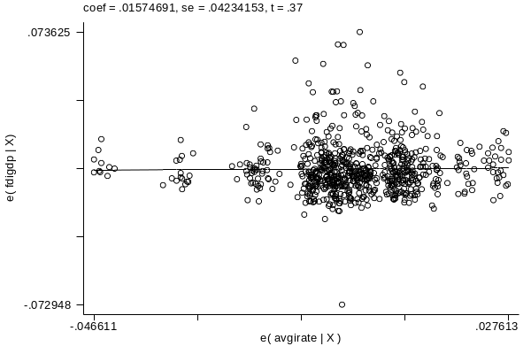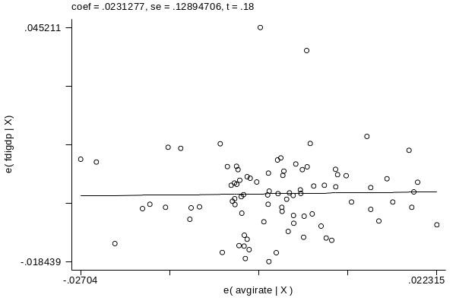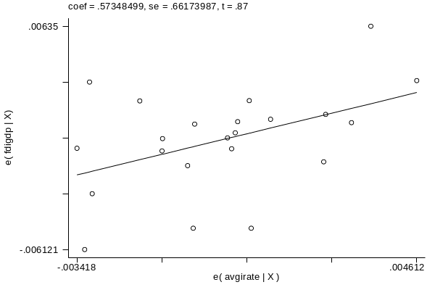

Figure 4.3. Graphs of the Partial Correlation of Foreign Direct Investment with G3 Average Inflation

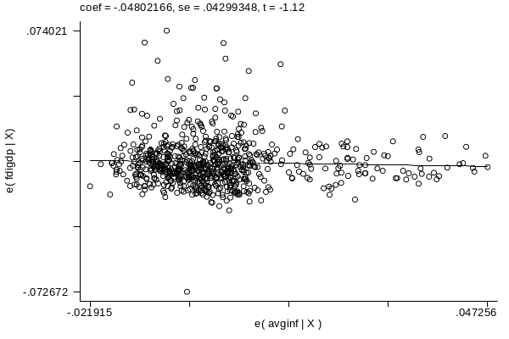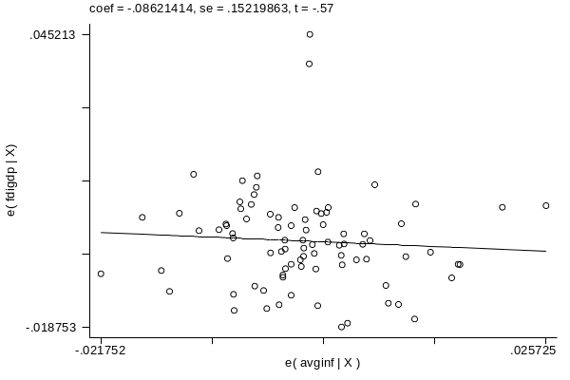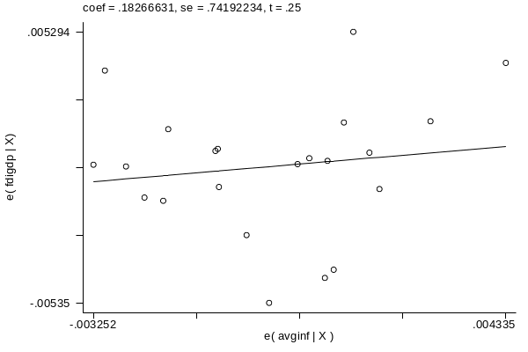

Figure 4.4. Graphs of the Partial Correlation of Foreign Direct Investment with World Stock Market Return

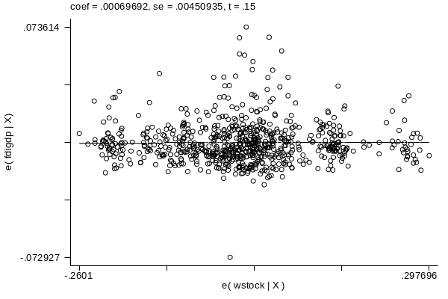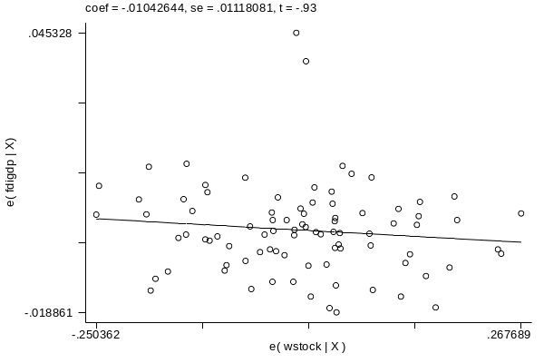
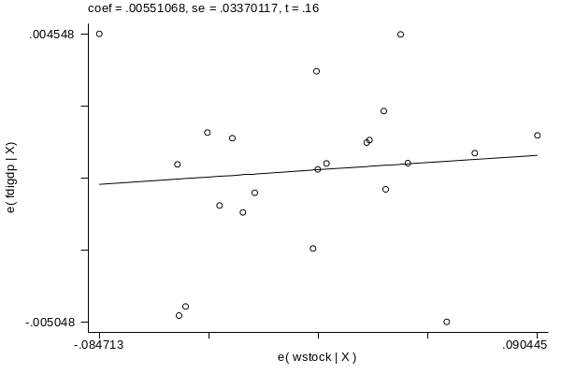

Figure 4.5. Graphs of the Partial Correlation of Foreign Direct Investment with U.S. Yield Curve Slope

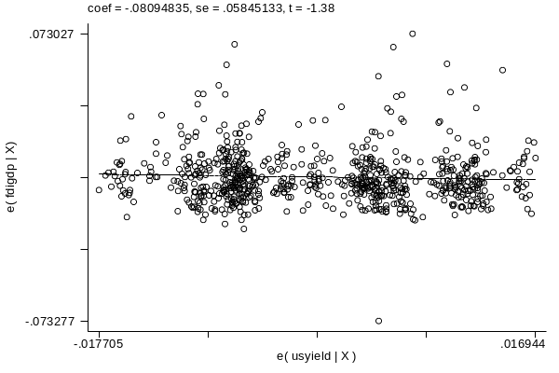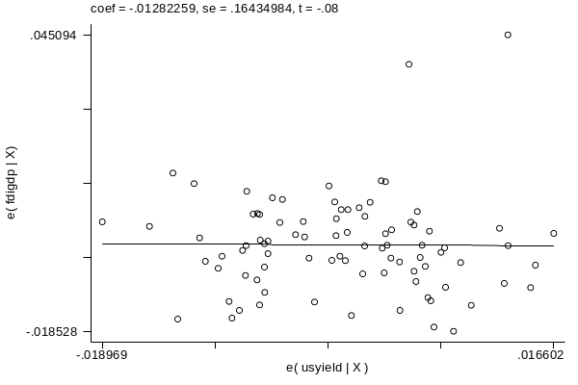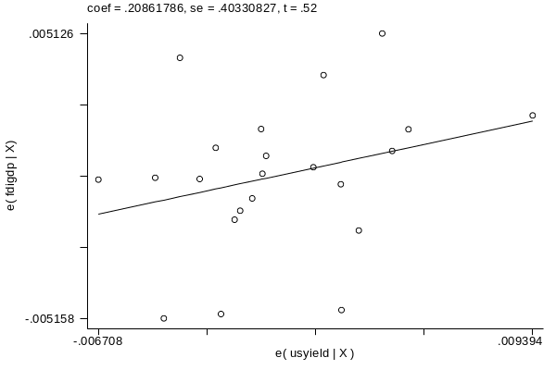

Figure 4.6. Graphs of the Partial Correlation of Foreign Direct Investment with U.S. Credit Spread

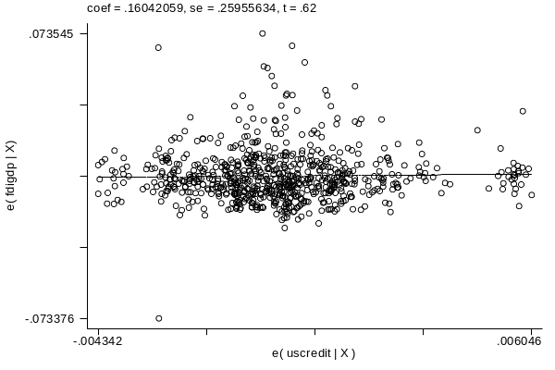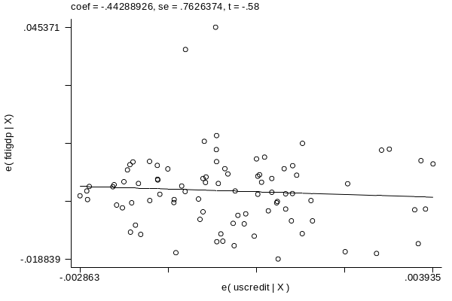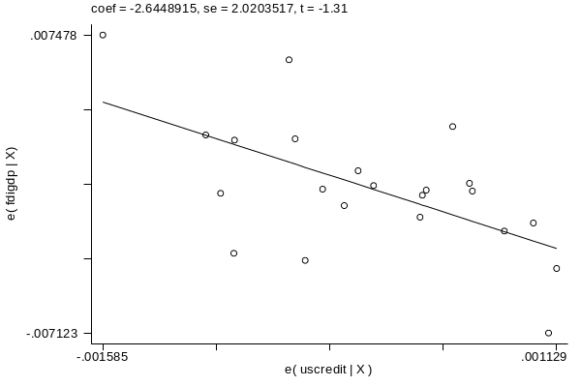

Figure 4.7. Graphs of the Partial Correlation of Foreign Direct Investment with World Growth

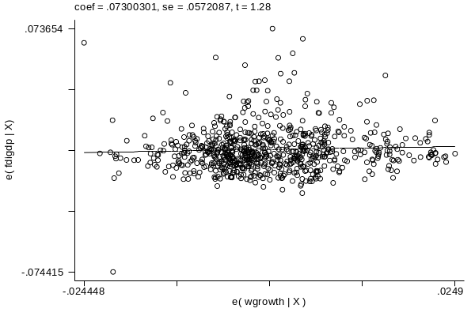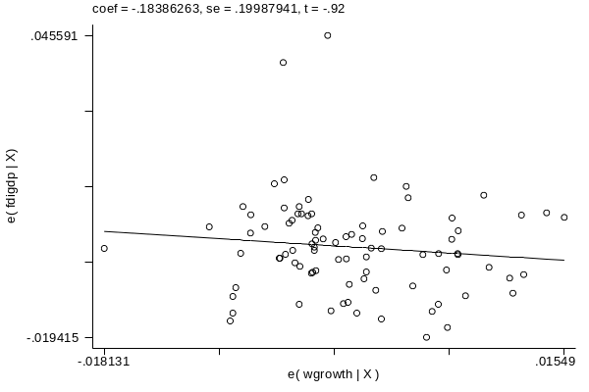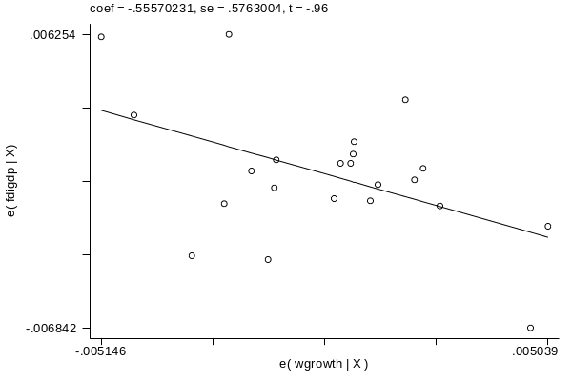

Figure 4.8. Graphs of the Partial Correlation of Foreign Direct Investment with Trade Openness

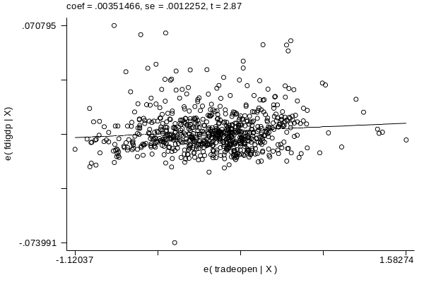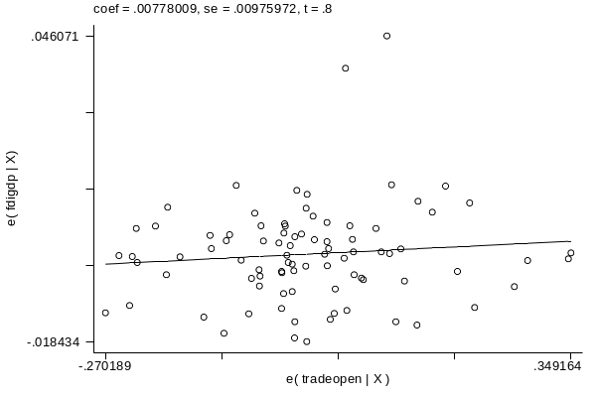
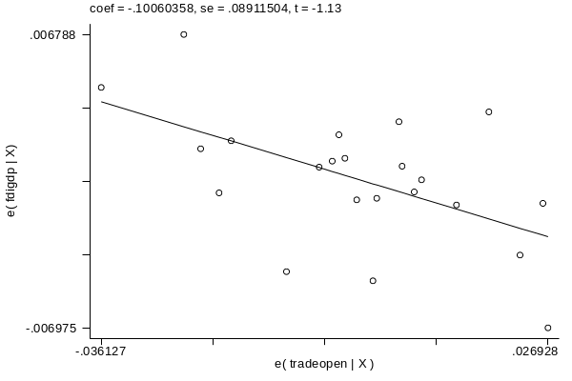

Figure 4.9. Graphs of the Partial Correlation of Foreign Direct Investment with REER Growth

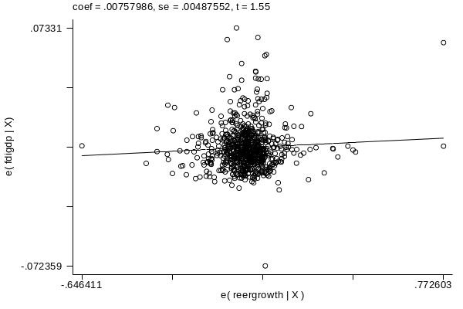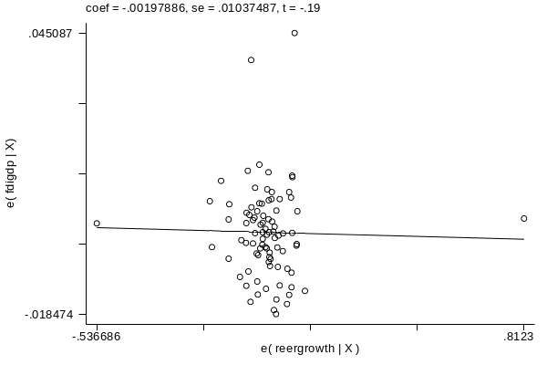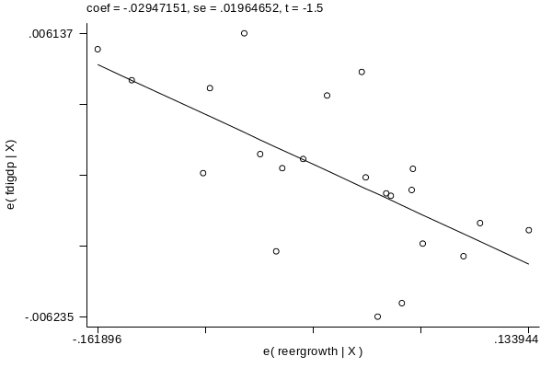

Figure 4.10. Graphs of the Partial Correlation of Foreign Direct Investment with GDP Growth

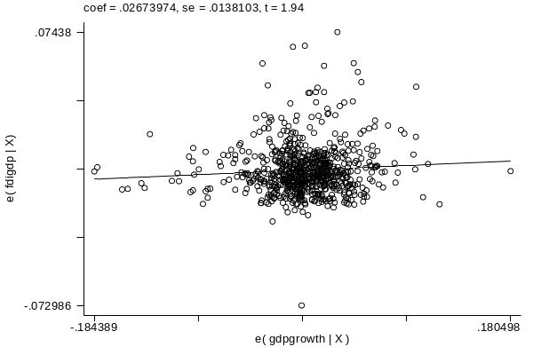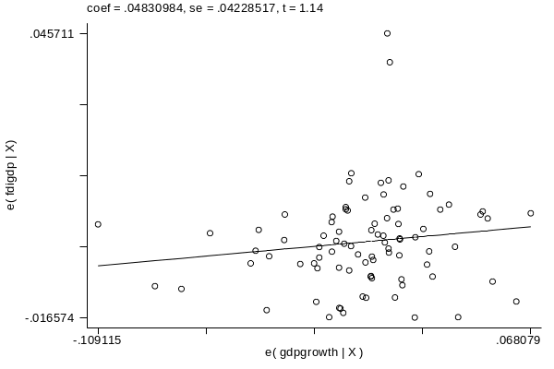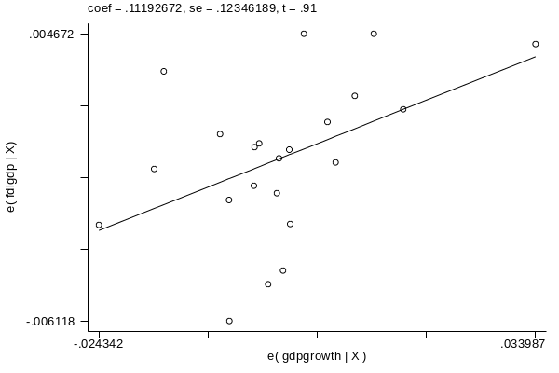

Figure 4.11. Graphs of the Partial Correlation of Foreign Direct Investment with Financial Depth

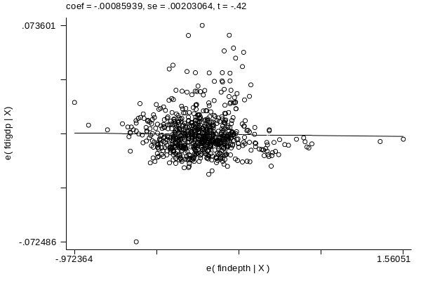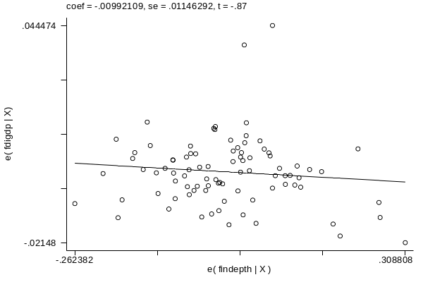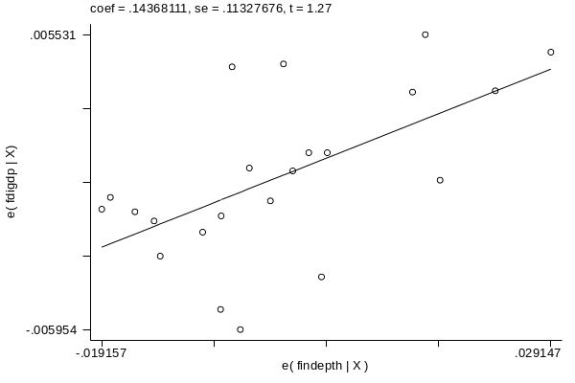

Figure 4.12. Graphs of the Partial Correlation of Foreign Direct Investment with Government Consumption

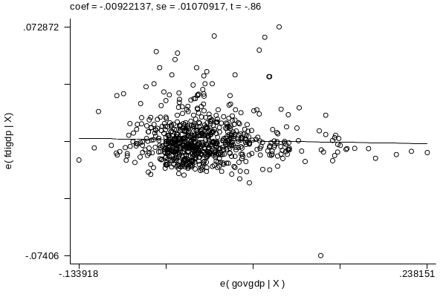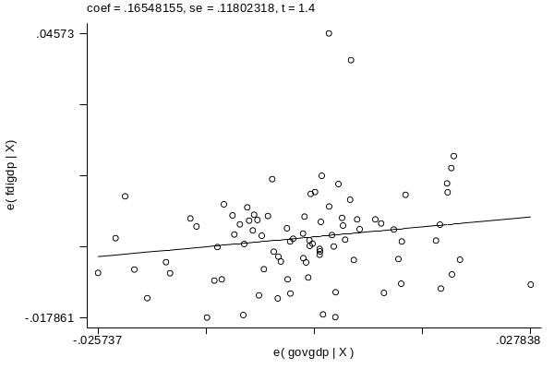
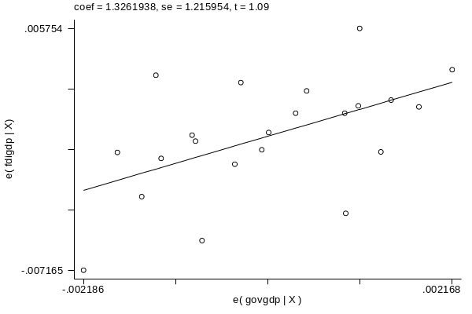

Figure 4.13. Graphs of the Partial Correlation of Foreign Direct Investment with Institutional Quality

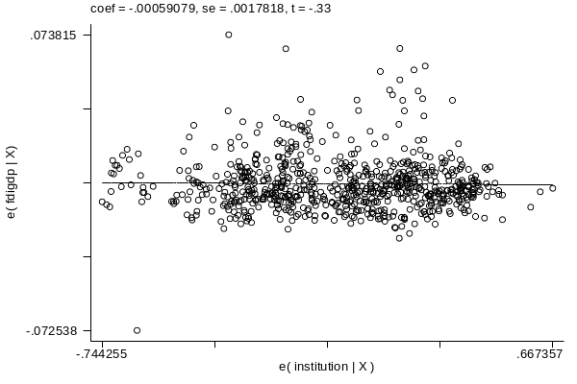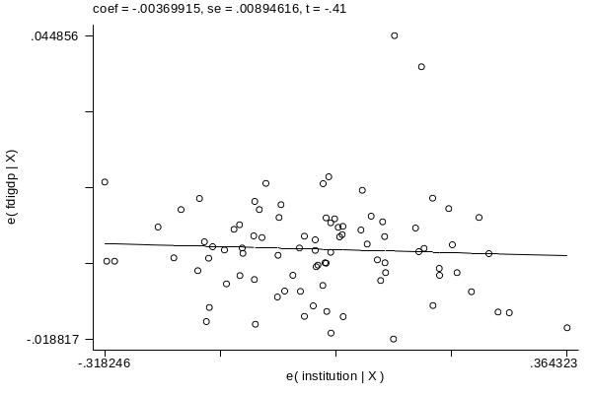

Figure 4.14. Graphs of the Partial Correlation of Foreign Direct Investment with GDP Growth Volatility

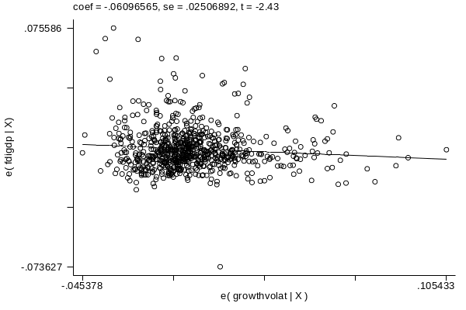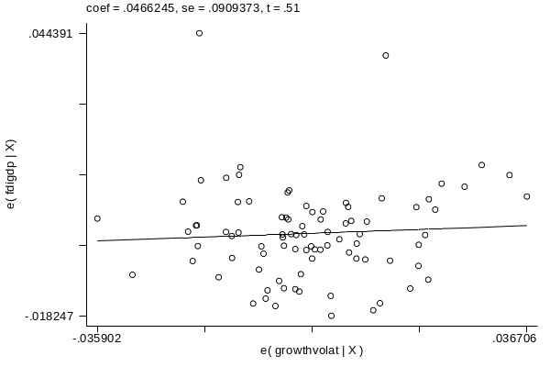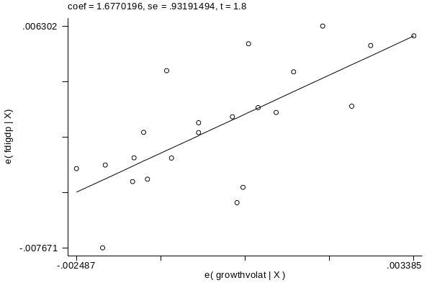

Figure 4.15. Graphs of the Partial Correlation of Foreign Direct Investment with Terms of Trade Volatility

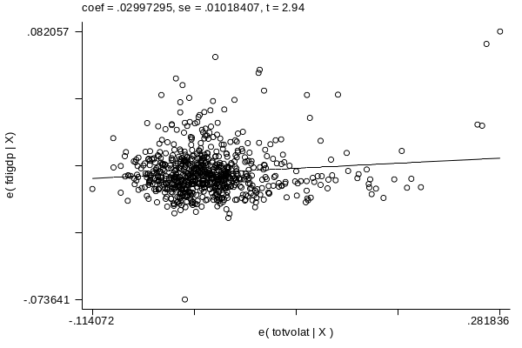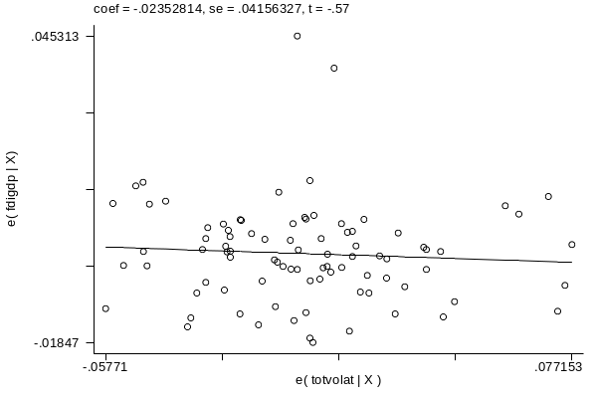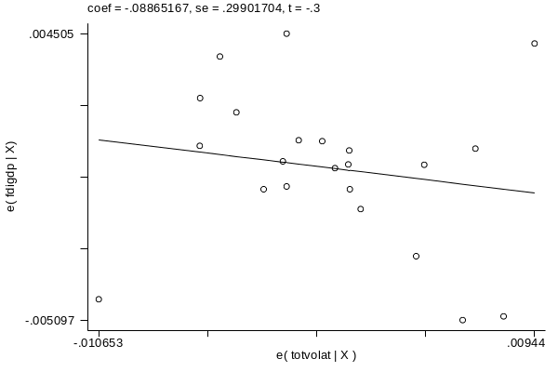

Figure 4.16. Graphs of the Partial Correlation of Foreign Direct Investment with REER Volatility

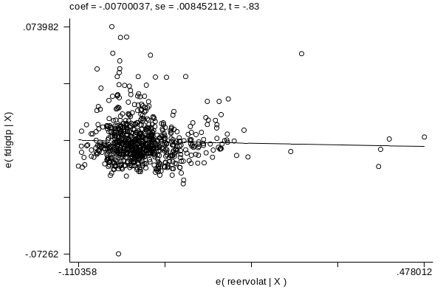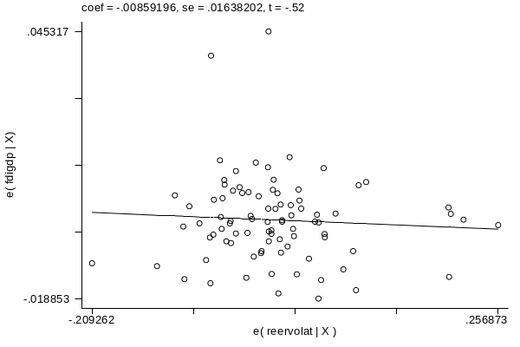
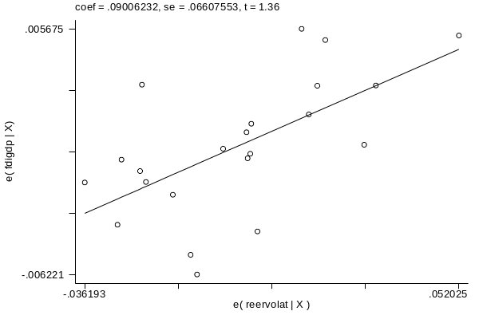

Figure 4.17. Graphs of the Partial Correlation of Foreign Direct Investment with Privatizations

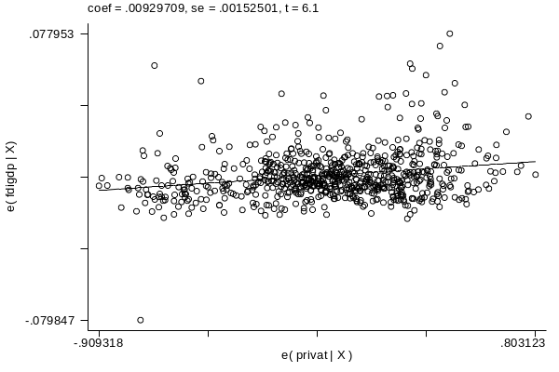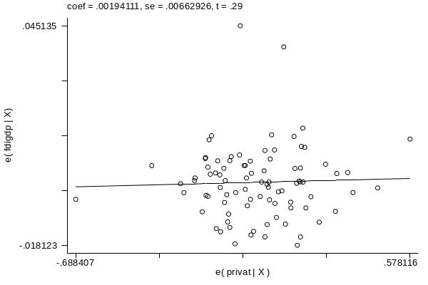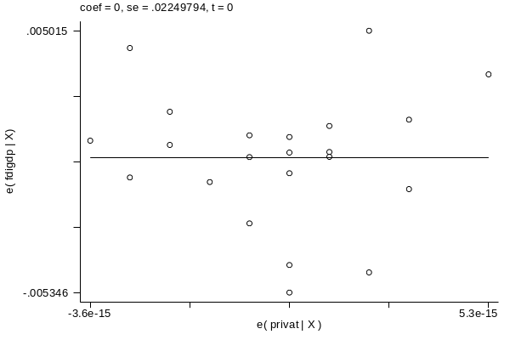

Figure 4.18. Graphs of the Partial Correlation of Foreign Direct Investment with Balance of Payments Restrictions

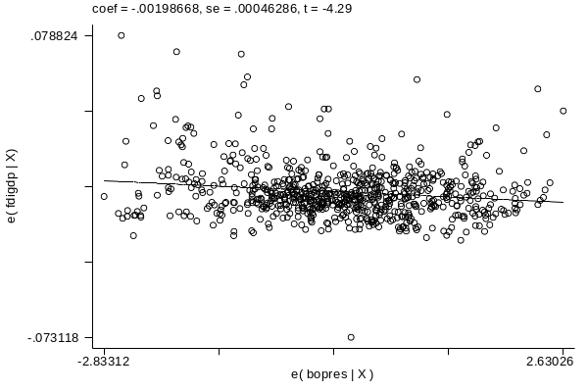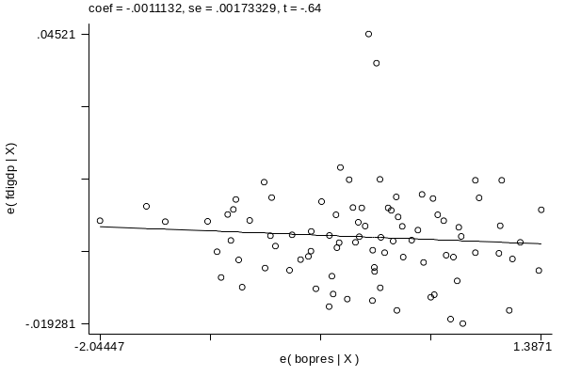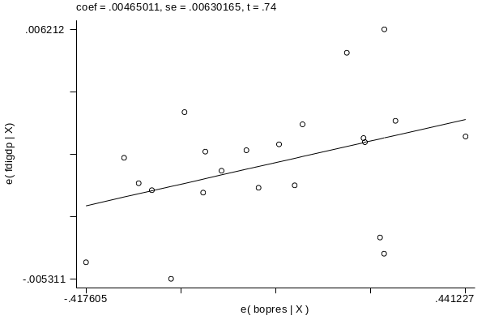

Figure 4.19. Graphs of the Partial Correlation of Foreign Direct Investment with Stock Market Traded Value

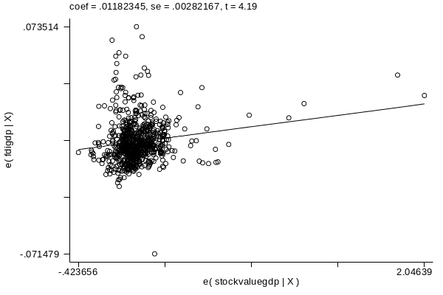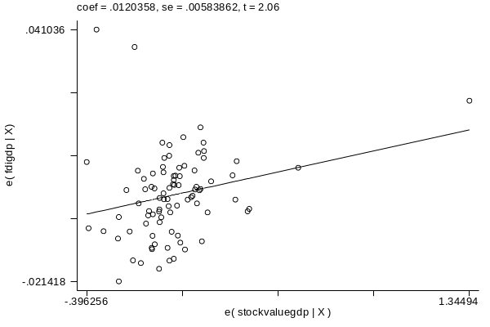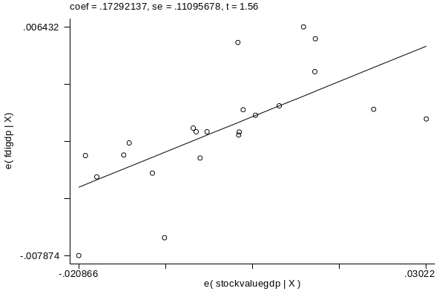

Figure 4.20. Graphs of the Partial Correlation of Foreign Direct Investment with Wages

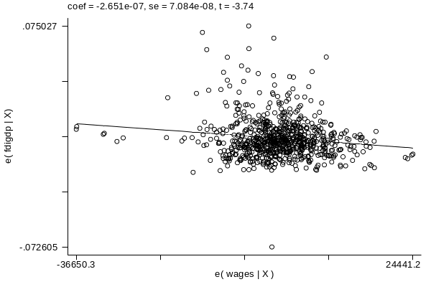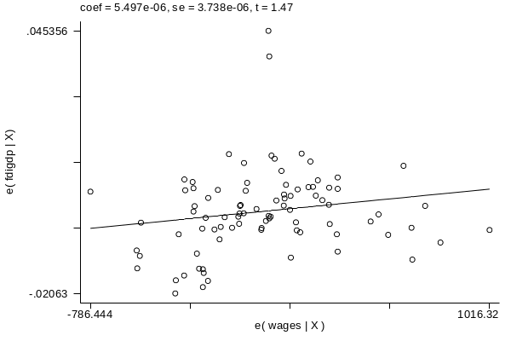
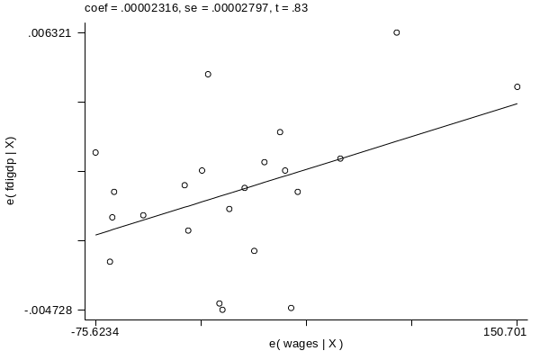

The results from the regressions turn out to be significant for the subsample of Southeast Asia countries, implying the set of explanatory variables used in the regression are useful to explain foreign direct investment in these countries. Let us turn now to the results on global variables; the G-3 average bond rate, the US yield curve and world GDP per capita carry negative coefficients in the case of the whole world’s sample as well as in the Southeast Asian countries. As noted by Albuquerque, Loayza and Servén, this indicates an increase in any of these variables will lead to an improvement in the performance of international assets. For the case of Philippines the correlations imply that Foreign Direct Investment reacts more strongly to shocks, but the direction is basically the same for all the global variables; this is logical, as the Philippines is just acting as a small economy in the whole world, and hence, is subject as a “price-taker” in financial markets, to exogenous shocks, more than the whole world or a relatively large economy (all of Southeast Asia) is. The sign however changes in the case of inflation and on the World Stock Market return, which is negative for the case of the Philippines. This reflects other stock markets being a substitute for investment in the Philippines; about inflation we may say that that as inflation rises in these countries, investment the opportunity cost of investing in the Philippines decreases and hence investment is shifted towards it.

Turning to the case of local variables, we can see that the coefficients of GDP growth and trade openness are positive in the case of the whole world sample and of the Southeast Asia countries. However, the coefficients of the ratio of Government expenditures to GDP turn out to be significantly negative. For the case of the Sotuheast Asian countries and the Philippines the correlations show a positive relation, and this may be sue to government spending direcetd towards infrastructure, and taxes to investment not being the source for government income, hence the tax regime being “good” for investment.

Trade openness carries a higher coefficient in the sample of Southeast Asian countries, which may reflect the fact that the degree of trade openness in this area is of extreme importance for investors, as the whole region during this period was similar in the fundamentals of the economy, at the time being exposed to an increasing demand for labour and the establishment of industry in this region. The degree of openness may reflect the differences in tax regimes and investment benefits that would reduce the costs of investment by foreigners in the developing region. However, for the particular case of Philippines, the correlation is negative, which may be probably due to an exogenous decrease in foreign direct investment, along with trade openness going up, which may yield this result.

Another important local variable to consider is GDP growth, which statistically similar in the whole world and the Southeast Asia samples. The important thing is that an environment of economic growth, reflecting overall productivity growth, along with fewer restrictions to trade makes investors shift their resources towards these countries. In the case of government expenses, the negative coefficient may be a reflection of a higher tax regime, implying the net return of investment is lowered and investment would shift to these countries in the case of lower taxation, thus not deterring investment. The coefficient on financial depth is positive for the case of the whole world, and negative for the Southeast Asia countries.

As we can see, the results obtained indicate a strong partial correlation between foreign direct investment and terms of trade volatility. However, the coefficients for both growth volatility and real exchange rate volatility are slightly negative. This just suggests that even though macroeconomic stability is important for investors, as their assets are hence less subject to exogenous shocks in the economy. For both the case of the real exchange rate volatility and the terms of trade volatility, the coefficients are positive in both cases for real exchange rate and it’s positive in the Southeast Asia sample for the terms of trade. However, the coefficients aren’t significant in any of both samples; same is the case of Philippines.

The results obtained from these regressions suggest the amount of foreign direct investment is predicted in both the case of the whole world sample and the Southeast Asia sample by the set of explanatory variables used in the regression.

Especially due to the lack of technological transfer in a host country that allocates foreign investment mainly in labour intensive sectors (see Loungani and Razin), once the foreign direct investment is reallocated, we get the results on growth that can be observed in the Philippines, namely, it doesn’t grow as do the other Asian countries; of course not all of this can be explained by foreign direct investment, but this is the most plausible explanation that can be obtained from our results.

Another possible explanation is the lack of positive externalities that generate spillovers in the host economy. Referring to this point, we can say that productivity of domestic firms may be decreased due to the presence of multinationals as the production is redirected to other market segments that are less profitable. Also, the amount of schooling needed in manufacturing is not as high as in other kinds of industries, hence lowering the generation of positive spillovers in the host country (See Hanson).

Another key factor may be the rise of other substitute host countries, as China, that offer a higher return on investments, as it has become the main target for foreign direct investment, hence affecting the amount of investment in the Philippines. A similar thing has happened for other Asian countries as Singapore or Malaysia, but apparently the effect of emerging investment opportunities hasn’t been so harsh on these countries as it has been in Philippines, as is stated in the FDI Confidence Index of the Global Business Policy Council.

The graphs of the partial correlations between foreign direct investment and the explanatory variables can be seen in the above graphs, and interpretation is made according to these partial correlations.

First of all, let’s note that the partial correlation between foreign direct investment and the average interest rate is positive, and so is the one with the slope of the US yield curve, which suggests that an increase in these variables lowers the performance of assets in Philippines.

We can use the estimation of the model using the data for Asian countries to predict what would have been the proportion of FDI over GDP in Philippines have this country perform at the same level as other countries in the region.

Figure 4.21. Observed and predicted FDI/GDP: Philippines.
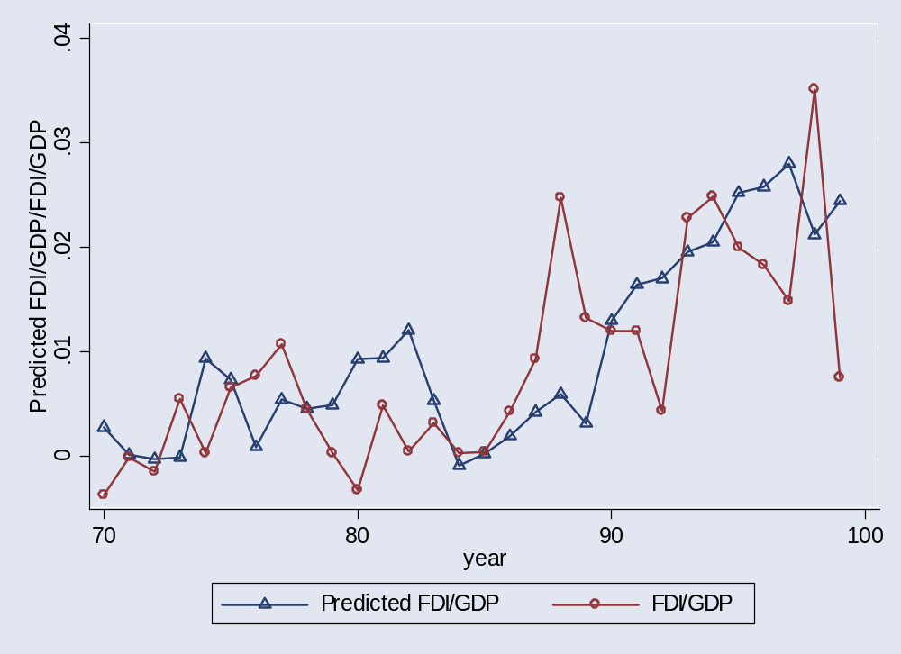

Figure 4.21 depicts the observed value of the ration of FDI over GDP jointly with the predicted value using specification (1) in table 4.4. It is interesting to notice that the proportion of FDI was higher than the predicted in the second half of the 80, opposite to what happened during the first half. During the 90’s the prediction has been, with the exception of 3 years, above the actual value, which has shown a high degree of volatility. The recent drop in FDI is particularly worrisome since the prediction, after the Asian crisis, shows clear signs of recovery.

5. Conclusions.

5.1. Independently of the source of data (the doing business database, the investment climate assessment, the global competitiveness report, etc.) the business climate of Philippines is one of the worst of the South East of Asia.

5.2. This bad investment climate together with explicit policies from the government hurts very much foreign direct investment.

5.3. The lack of investment, in part due to the low level of FDI compare with other countries in the same region and similar level of development, and the low quality of skills make it difficult to increase labor productivity and create new jobs.

5.4. Since the size of the firms is a very important determinant of labor productivity the lack in FDI has a negative impact on the productivity of the Philippine economy.

REFERENCES

Agrawal, Pradeep. Economic Impact of Foreign Direct Investment in South Asia. Indira Gandhi Institute of Development Research, January 2000

Albuquerque, R., Loayza, N. and Servén, L. World Market Integration Through the Lens of Foreign Direct Investors.

Global Business Policy Council. FDI Confidence Index. September 2002, volume 5.

Hanson, Gordon H. Should Countries Promote Foreign Direct Investment? UN Conference on Trade and Development. G-24 Discussion Paper Series no.9 February 2001.

Haskel, J., Pereira, S. and Slaughter, M. Does Inward Foreign Direct Investment Boosts the Productivity of Domestic Firms? NBER Working Paper Series. Working Paper 8724 January 2002.

Lim, Ewe-Ghee. Determinants of, and the Relationship Between, Foreign Direct Investment and Growth: A Summary of the Recent Literature. IMF Working Papers. Internation al Monetary Fund, 2001.

Loungani, Prakash and Razin, Asaaf. How Beneficial is Foreign Direct Investment for Developing Countries?

Markusen, James R. and Venables, Anthony J. Foreign Direct Investment as a Catalyst for Industrial Development.

National Statistical Coordination Board. Tables and charts of composition of FDI in the Philippines.

Dollar and Kray (2001), Besley and Burguess (2003) or Ravallion (2001).
This resilience has been not observed in Indonesia due to political instability issues.
Unfortunately they do not consider the indices of investment climate or doing business. The basic reason is that all those indices are quite recent while the sample of Alburquerque, Loayza and Seven (2004) goes back up to 1970.

